Hello Tilden Students,
How are you? We hope you are Happy and Healthy! The Counseling Department has a fun project that we would like for you to get involved in through cooking since you are spending a lot of time inside with your family.
We are starting a Virtual Cookbook where you can go to share your favorite cooking recipes with your peers. The Counseling Department will be compiling recipes submitted by students during the month of May. If you are interested in participating, please send a copy of your favorite recipe to Ms. Cooper at Nikia_N_Cooper@mcpsmd.org (word or PDF copy).

For added fun, take a picture of you and your family making your favorite dish and send it to Ms. Cooper @ Nikia_N_Cooper@mcpsmd.org. Please remember to get your parents/guardian’s permission for the photo to be posted on the Counseling website. Your parent/guardian must send me an email stating it is ok to post the picture to the website. Also, students please get parent/guardian permission to use the stove or oven before cooking your favorite dish. See Counselor’s favorite recipe below
Rainbow Fruit Cups
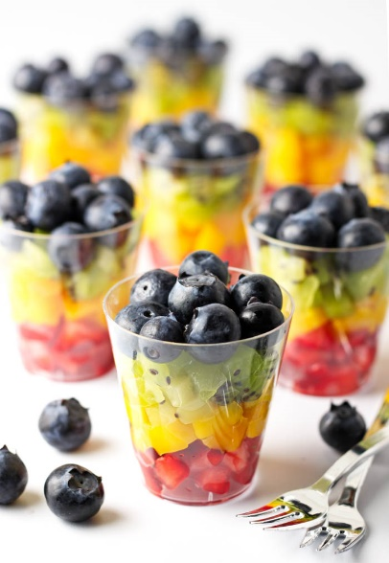

Ingredients
- 20 2-ounce plastic cups
- 1½ pounds strawberries
- 3 mangoes, peeled
- 5 kiwis, peeled
- 1pound blueberries
Instructions
- Chop washed strawberries, mangoes, and kiwis into tiny pieces (as pictured).
- Add strawberries to the bottom of cup followed by mangoes, kiwis, and blueberries.
- Store in the fridge and serve within a few hours. Enjoy!

