* Required Info

* PARENT/GUARDIAN

REGISTRATION FORM
□ Check here if this is a new address, phone number or email address. Please print. This form may be copied.
Last Name * | First Name * |  |  | Birthday (mm/dd/yy) * |  | Email
Address * |  |  | City * |  |  |  | State * | ZIP *
Home Phone * |  | Work Phone* |  |  | Cell Phone *

*EMERGENCY
CONTACT
Name Relationship Phone

*Participant’s Name (Last, First) *Birthday (mm/dd/yy) *Sex *Activity Name *Grade *Activity #
 |  |  | RecXtra SSI MS –  Cooking Tuesday |  | #64601

*SIGNATURE IS REQUIRED*
*Participant or Parent/Guardian Signature

Date
The participant assumes all risks associated with participation in the program; neither the County nor Montgomery Parks/M-NCPPC assumes any liability for injury or damages arising from participation in the program. Due to the strenuous nature of some activities, each participant is encouraged to consult his or her physician concerning fitness to participate in the program. The participant consents to emergency treatment. The participant also consents to the County and Montgomery Parks/M-NCPPC’s use of the participant’s image and likeness as shown in any photographs, videotapes, motion picture film, or electronic images, and any audio recordings made of the participant’s voice in whatever way the County and Montgomery Parks/M-NCPPC desires, including television, print and Internet websites. Furthermore, the participant consents that such photographs, films, recordings, electronic images shall be the sole property of the County and Montgomery Parks/M-NCPPC. If the participant is a minor, the parent of guardian approves his or her participation in the program. Neither the instructor nor any staffs are responsible for children prior to or after scheduled program.

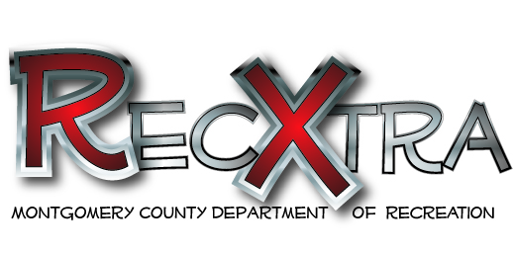
NEW!

2019 SSI MS
AFTERSCHOOL ACTIVITIES

Please fill out the form completely (on the back) and return the form to Mrs. Nicole Reaves, SSI’s After School Activities Coordinators. All clubs meet from 3:10-4:20 p.m. Rec Extra programs are offered at no cost to you. If you have questions, please contact Mrs. Nicole Reaves at the school at 301-650-6544
Nicol_J_Reaves@mcpsmd.org or Alessandra Flores with Recreation at 240-777-4938 or Alessandra.Flores@montgomerycountymd.gov
RecXtra Cooking Tuesday#64601
Tuesday’s from January 15th, 2019 – Feb 26th, 2019

Participants will explore the world’s foods and learn about the customs of people from around the world. Learn the basic skills of preparing and cooking foods and working cooperatively with others. Sponsor: Ms. Moore. Room: 139
MAX-12 STUDENTS

STAY TUNED TO SCHOOL ANNOUCEMENTS FOR UPCOMING ACTIVITIES THAT ARE COMING SOON AFTERSCHOOL TO SILVER SPRING INTERNATIONAL MS!

Montgomery County Recreation is committed to compliance with the Americans with Disabilities Act (ADA). Please contact a Therapeutic Recreation Specialist at 240-777-6870 or rec.mainstream@montgomerycountymd.gov to request accommodations.

