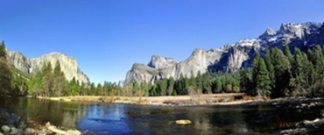

Hi Parents,

The West Coast trip is an awesome way for your child to explore the WEST COAST through STEM-Science, Technology, Engineering, and Math! Your WorldStrides trip is all inclusive!

Here is what is included:

* Students enjoy three meals a day while traveling.
* All air travel is included, as well as the busses once you land in California!
* Hotels are included, too!
* Every activity and attraction that the students will participate in while in California is already taken care of!
* Education journals and ID badges for every student are passed out before departure.
* Access to our Doctor’s on Call network, Tour Central, and 24- hour Course Leader is always available, as well!
* High school credits

[Check out the trip to California](https://urldefense.proofpoint.com/v2/url?u=https-3A__worldstrides.com_itineraries_west-2Dcoast-2Dscience-2Dand-2Dtechnology_&d=DwMFAg&c=fgAH0TEak9hSJygxoVsafg&r=zRgE0tfaPRpj_JlKkEmgIwgaGclIuoPRJ3pCGlM588E&m=qGRWKCpPdGrtzY75e5emq0s-V7M-YrgoXcWo9oe95rs&s=OeKL-3KKgeJR1uO912k4pss8DXtR8m2n7oHcNCPqQgI&e=) **Our Trip dates are June 22-27, 2019**

Robert Frost Middle School **Trip ID: 160657**

The deadline to sign up for the trip is Math 10th!

* online at worldstrides.com/signup
* by phone at 800-468-5899
* by mail by completing the registration form included in your student invitation

 Questions? Contact Jennie Woo jennie_M_Woo@mcpsmd.org