WHAT YOU NEED TO KNOW FOR:

LEARNZILLION 8

Name: _______________

Due on the second Friday of the school year!

The Learnzillion Math 8 teachers have selected the following topics for summer review. Students should complete the attached practice problems. Online resources for students who need help are provided in each section. Additional online practice can be found at the resource sites and are listed below.

Topics:
- Finding Slope from 2 Points
- Four Quadrant Coordinate Graphing
- Place Value
- Plotting Points
- Comparing Numbers
- Ordering Integers
- Adding with Negative Numbers

Finding Slope from 2 Points
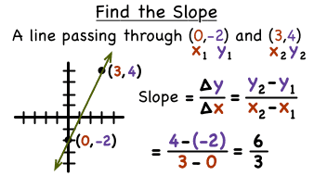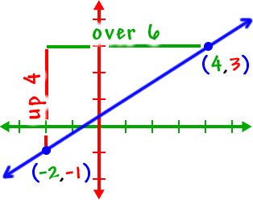

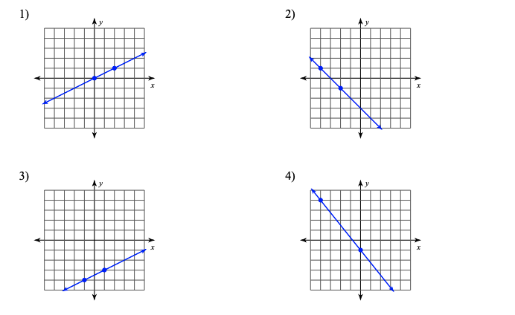
Determine the slope by using the graph or the equation. This video may help: https://youtu.be/zihsQC0IUd8

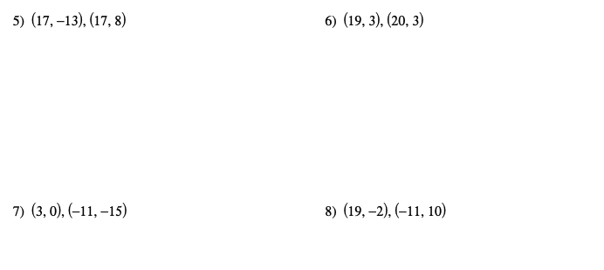
Four Quadrant Coordinate Graphing
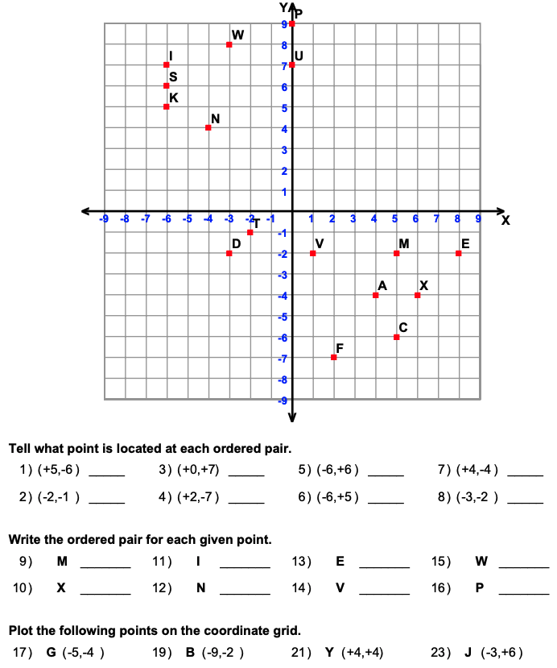
Place Value
Use this place value chart to help you determine the correct answer.

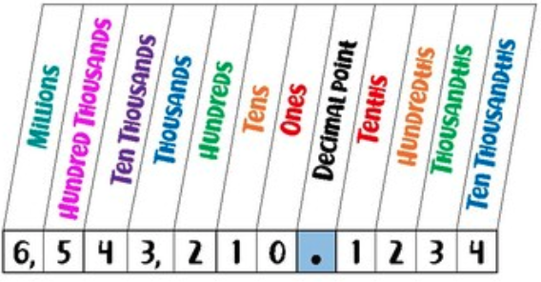
1) What digit is in the tens place in the number 7,836? _____________________________
2) What digit is in the hundreds place in the number 1,846? ____________________________
3) What digit is in the thousands place in the number 6,587? ____________________________
4) What digit is in the ten thousands place in the number 64,953? ________________________
5) What digit is in the hundred thousands place in the number 5,289,647? ________________
6) What digit is in the millions place in the number 8,231,965? _________________________
7) What digit is in the ones place in the number 7,859,324? _________________________
8) What digit is in the tens place in the number 3,485? _________________________
9) What digit is in the hundreds place in the number 498,321? _________________________
10) What digit is in the thousands place in the number 6,529? _________________________
11) What place is the 9 at in the number 6,295,831? __________________________________
12) What place is the 2 at in the number 275,684? __________________________________
13) What place is the 9 at in the number 9,683,745? __________________________________
14) What place is the 1 at in the number 1? __________________________________
15) What place is the 2 at in the number 64,127? __________________________________
16) What place is the 8 at in the number 76,835? __________________________________
17) What place is the 2 at in the number 42,316? __________________________________
18) What place is the 6 at in the number 863,192? __________________________________
19) What place is the 9 at in the number 958,142? __________________________________
20) What place is the 4 at in the number 4,796,318? __________________________________
Plotting Points
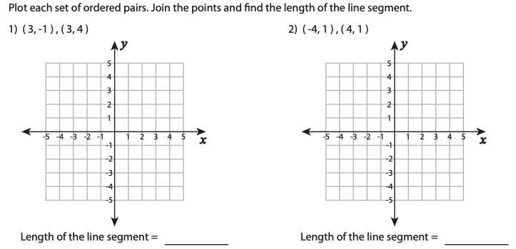

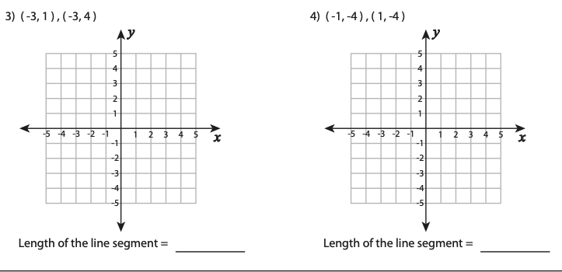
Comparing Numbers
Use this number line to help you compare the two values using the inequality symbol or the equals symbol.

smaller greater
values values
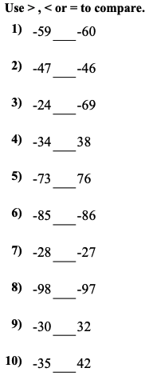
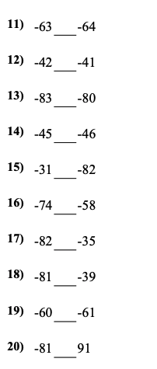
You may also use this website to create your own number line.
https://www.helpingwithmath.com/printables/others/NumberLineGenerator01.htm

Ordering Integers
Use the following integers number line to help you order the values.
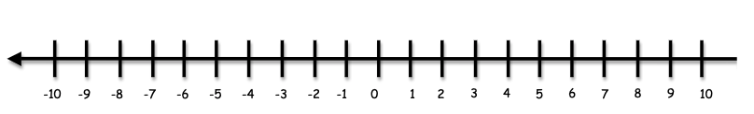
Circle the row that has the numbers ordered in the correct order.
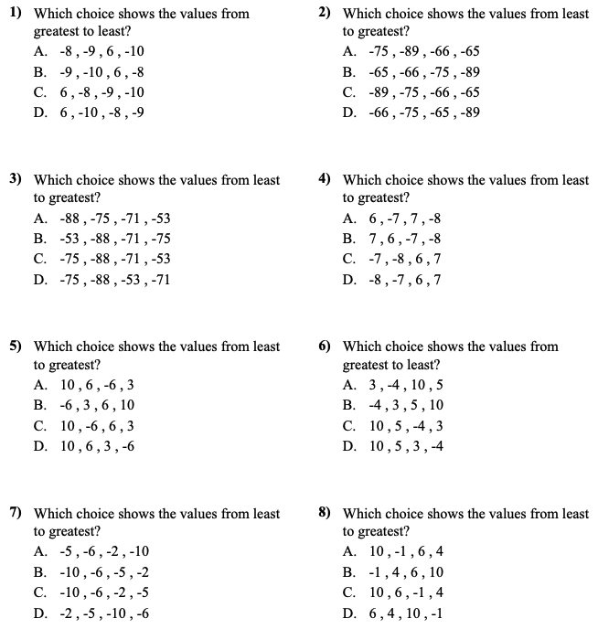

Adding with Negative Numbers
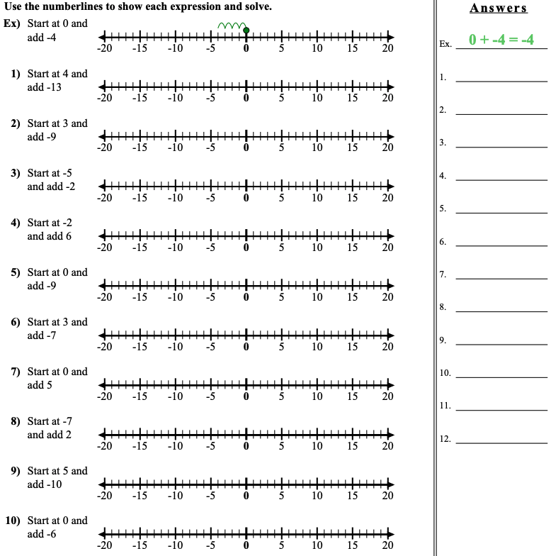
Move forward 6
Move back 9
Move back 13

