WHAT YOU NEED TO KNOW FOR:

LEARNZILLION 7

Name: _______________

Due on the second Friday of the school year!

The Learnzillion Math 7 teachers have selected the following topics for summer review. Students should complete the attached practice problems. Online resources for students who need help are provided in each section. Additional online practice can be found at the resource sites and are listed below.

Topics:
- Rational Numbers (fractions, decimals, integers)
- Proportions (Using Ratios and Rates)
- Arithmetic Operations and Word Problems
- Variables and Expressions
- Inequalities
- Geometric Reasoning (Identifying Shapes)

For online practice, go to one of these websites and search the topic:
- Khan Academy Review of LZ 6 Curriculum https://www.khanacademy.org/math/illustrative-math/6th-grade-illustrative-math
- Cool Math for Kids https://www.coolmath4kids.com/math-games/sixth
- Math Playground https://www.mathplayground.com/grade_6_games.html
- Hooda Math https://www.hoodamath.com/games/sixth-grade.html
- Math Play http://www.math-play.com/6th-grade-math-games.html
- Math Game Time http://www.mathgametime.com/grade/6th-grade

Rational Numbers
For extra support, visit the Khan Academy video on negative numbers here https://www.khanacademy.org/math/arithmetic/arith-review-negative-numbers/arith-review-neg-num-intro/v/negative-numbers-introduction
https://www.khanacademy.org/math/cc-sixth-grade-math/cc-6th-negative-number-topic/cc-6th-neg-dec-frac-number-line/v/positive-and-negative-decimals-on-a-number-line

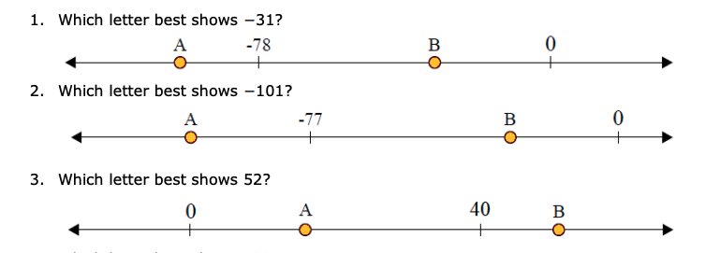
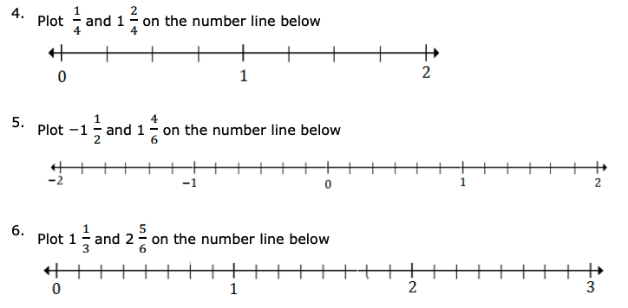

Ratios, Rates, and Percentages.
For assistance, go to Khan Academy, 6th Grade Mathematics: Ratios, Rates, and Percentages. https://www.khanacademy.org/math/cc-sixth-grade-math/cc-6th-ratios-prop-topic. You can login with your school Google account.

Note: To determine the percent of a number, we must first convert the percent into a decimal by dividing by 100 (which can be short-cut as moving the decimal point in the percentage two places to the left).
When you find equal ratios, it is important to remember that if you multiply or divide one term of a ratio by a number, then you need to multiply or divide the other term by that same number. You can determine the unit rate by dividing the first term of the ratio by the second term.

- The ratio of red to white flowers is 2:5. If both the number of red and white flowers are doubled, what is the new ratio of red to white flowers?

- Write the following as percents:
- $\frac{1}{2}$= b) 0.75 = c) $\frac{3}{8}$= d) 1.5 =

e) $\frac{2}{3}$= f) 5.3 = g) $\frac{7}{6}$= h) 1 =

- Maria ran a total of 12 miles over the course of 6 track practices. How many track practices would it take for Maria to run 16 miles? Solve using unit rates.

- Becky grew 6 plants with 2 seed packets. How many seed packets does Becky need to have a total of 12 plants in her backyard? Solve using unit rates.

- Sarah walked a total of 3 miles by making 2 trips to school. How many trips will Sarah have to make in all to walk a total of 12 miles? Solve using unit rates.

Arithmetic Operations. For assistance, go to Khan Academy, 6th Grade Mathematics: Arithmetic Operations. https://www.khanacademy.org/math/cc-sixth-grade-math/cc-6th-arithmetic-operations. You can login with your school Google account.

Note: When adding and subtracting decimals, the key is to line up the decimals above each other, add zeros so all of the numbers have the same place value length, then use the same rules as adding and subtracting whole numbers, with the answer having a decimal point in line with the problem.
To multiply decimals, the rules are the same as with multiplying whole numbers, until the product is determined and the decimal point must be located. The decimal point is placed the same number of digits in from the right of the product as the number of decimal place values in the numbers being multiplied.

To divide decimals by a whole number, the process of division is the same, but the decimal point is brought straight up from the dividend into the quotient.
Exponents are shorthand for repeated multiplication of the same thing by itself. The thing that's being multiplied is called the "base". This process of using exponents is called "raising to a power", where the exponent is the "power".

- 0.3 x 0.7 = _____ 6. 6.168 − 0.432 = _____

- 2.2 x 0.5 = _____ 7. 20 − 15.729=_____

- 10.5 x 3 = _____ 8. 8.54 + 0.251=_____

- 25$÷0.5$= _____ 9. $2^{4}$= _____

- 100 $÷2.5$= ____ 10. $4^{3}$= _____

Negative Numbers. For assistance, go to Khan Academy, 6th Grade Mathematics: Negative Numbers. https://www.khanacademy.org/math/cc-sixth-grade-math/cc-6th-negative-number-topic. You can login with your school Google account.
Note: The number line has no beginning and no ending, indicated by the arrow on both ends of the line. Negative numbers increase as you move to the left of the line, but the negative sign means the value of the number actually decreases. The negative sign tells you how far away the number is from the zero. So -3 means you are 3 steps away from 0 and -5 means you are 5 steps away from zero. Therefore, -5 is smaller than -3 because you are further away from zero.

- The employees were looking at their debts. Gomez is in $143.00 of debt; Cole has $203.00 of debt. Ford has $178.00 of debt. Simpson has a positive bank balance of $350.00. Who owes the most money?

- Henry’s room rent is $40. His electricity bill is $10 and food expenses are $15. His job deposited his salary of $60 into his bank account. What would be the balance remaining after paying his monthly expenses?

- Use > , < or = to compare.

  - -59 ___ -60

  - -47 ___ -46

  - -24 ___ -69

  - -34 ___ 38

  - -73 ___ 76

  - 55 ___ -55

  - -100 ___ 10

  - |-16| ___ 10

Variables and Expressions. For assistance, go to Khan Academy, 6th Grade Mathematics: Variables and Expressions.https://www.khanacademy.org/math/cc-sixth-grade-math/cc-6th-expressions-and-variables. You can login with your school google account.
- Students are trying to raise $250 for the track club. They have already made $50. How much do they need to earn to meet their goal?

- Sam was planting flowers for his garden. He had to plant 4 rose flowers for every jasmine flower he planted. If he plants 100 flowers in all, how many will be jasmine flowers?

- Julien has 20 songs. His friend bought him M more songs. Write an expression that shows how many songs Julien has now.

- Susi earned 80 points on the math project. Peyton earned B fewer points than Susi. Write an expression that shows how many extra points Susi earned.

- Write the expressions for each of the following:

- The sum of y and 7. 2

- The difference of z and 8

- The product of r and 15

d) The quotient of 8 and y

Equations and Inequalities. For assistance, go to Khan Academy, 6th Grade Mathematics: Equations and Inequalities. https://www.khanacademy.org/math/cc-sixth-grade-math/cc-6th-equations-and-inequalities. You can login with your school Google account.
Note: The key in equation solving is to isolate the variable, to get the letter by itself. In one-step equations, we merely undo the operation - addition is the opposite of subtraction and multiplication is the opposite of division. Remember the golden rule of equation solving: If we do something to one side of the equation, we must do the exact same thing to the other side.

1. 32 < b
Which value for y would make the inequality true?

a) 61 b) 32 c) 19 d) 27

2. 20 < y
Which value for y would make the inequality false?

a) 25 b) 42 c) 21 d) 13 3

3. 64 < y
Which value for y would make the inequality false?

a) 88 b) 64 c) 71 d) 37

Complete the following problems:

- 45 ÷ _____ = 9

- 63 ÷ _____ = 7

- 8 x _____ = 72

- ____ x 6 = 42

Identifying Geometric Shapes
Use the following chart to help you identify the different types. Congruent means the same size.

There is one obtuse angle.
All 3 angles are acute.
There is a right angle 90º
All 3 sides are different lengths
Two sides are congruent
All 3 sides are congruent
From math-salamanders.com

The tick marks indicate that the sides are congruent.

Directions:
- Circle the Equilateral Triangles
- Draw a box around the Iscosceles Triangles
- Color in the Right Triangles
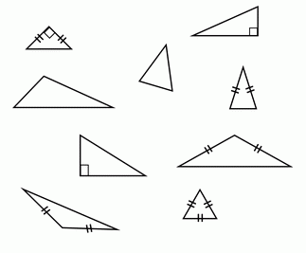

Quadrilaterals Reference Chart
Watch this video for more information https://www.youtube.com/watch?v=0OW2bU0So-4
 | Quadrilateral | Trapezoid  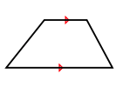 | Parallelogram  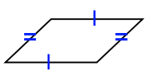 | Rhombus  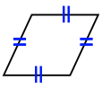 | Rectangle  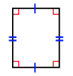 | Square  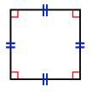
Has 4 sides | X | X | X | X | X | X
Has only one set of parallel lines  (the arrows) |  | X
Has two sets of parallel lines (the arrows) |  |  | X | X | X | X
Opposite sides are congruent  (the tick marks) |  |  | X | X | X | X
All 4 sides are congruent  (all the same tick marks) |  |  |  | X |  | X
Has 90 degree angles |  |  |  |  | X | X

Determine what names these shapes can be called (they might have more than one name)
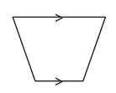 | 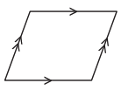 | 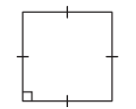 | 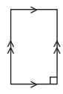
- Quadrilateral  - Trapezoid  - Parallelogram  - Rhombus  - Rectangle  - Square | - Quadrilateral  - Trapezoid  - Parallelogram  - Rhombus  - Rectangle  - Square | - Quadrilateral  - Trapezoid  - Parallelogram  - Rhombus  - Rectangle  - Square | - Quadrilateral  - Trapezoid  - Parallelogram  - Rhombus  - Rectangle  - Square

Determine what the most specific name is for each of these shapes (just one answer)
- Quadrilateral  - Trapezoid  - Parallelogram  - Rhombus  - Rectangle  - Square | - Quadrilateral  - Trapezoid  - Parallelogram  - Rhombus  - Rectangle  - Square | - Quadrilateral  - Trapezoid  - Parallelogram  - Rhombus  - Rectangle  - Square | - Quadrilateral  - Trapezoid  - Parallelogram  - Rhombus  - Rectangle  - Square

