WHAT YOU NEED TO KNOW FOR:

MATH 6

Name: _______________

Due on the second Friday of the school year!

The Mathematics 6 teachers have selected the following topics for summer review.
Students should complete the attached practice problems. Online resources for students who need help are provided in each section. Additional online practice can be found at the resource sites and are listed below.

Topics:
Whole Number Operations: Multiplication and Division
Fractions and Decimals: Addition, Subtraction, Comparing/Ordering

For online practice, go to one of these websites and search the topic:
Cool Math for Kids https://www.coolmath4kids.com/math-games/fifth
Math Playground https://www.mathplayground.com/grade_5_games.html
Hooda Math http://www.hoodamath.com/games/fifth-grade.html
Math Play http://www.math-play.com/5th-grade-math-games.html
Math Game Time http://www.mathgametime.com/grade/5th-grade

Whole Number Multiplication and Division Review
For assistance, go to Khan Academy, 5th Grade Mathematics: Multiplication and Division. You can login with your school Google account.
https://www.khanacademy.org/math/cc-fifth-grade-math/multiplication-and-division

Multiplying and Dividing Whole Numbers: Show all the steps you take to find the products and quotients.
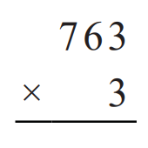 | 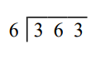
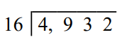 | 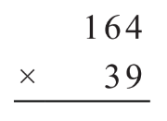
405 x 2 | 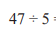
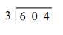 | 67 x 12
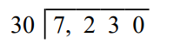 | 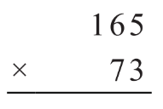

Fractions and Mixed Number Review
For assistance, go to Khan Academy, 5th Grade Mathematics: Fractions. You can login with your school Google account.
https://www.khanacademy.org/math/cc-fifth-grade-math/cc-5th-fractions-topic
Ordering Fractions: Place in order from least to greatest.
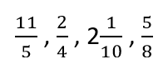
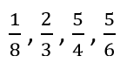

Adding and Subtracting Fractions: Show all the steps you take to find the sums and differences. Remember to write all answers as fractions less than one or mixed numbers.
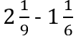
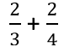
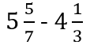
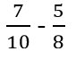
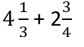
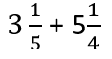

Decimal Fractions (Decimals) Review
For assistance, go to Khan Academy, 5th Grade Mathematics and search decimals. You can login with your school Google account.
https://www.khanacademy.org/math/cc-fifth-grade-math

Ordering Decimals: Place in order from least to greatest.
6.81, 6.37, 6.52, 6.5, 6.25
2.216, 2.149, 5.75, 2.59, 2.684

Adding and Subtracting Decimal Fractions: Show all the steps you take to find the sums and differences.
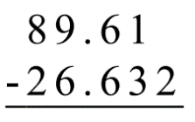 | 67.415 - 24.302
78.9 - 55.779 | 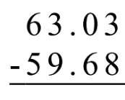
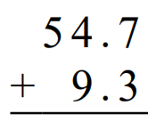 | 46 + 39.5

