**WHAT YOU NEED TO KNOW FOR:**



**GEOMETRY**

**Name: _______________**

**Due on the second Friday of the school year!**

References and Links to Help

Vocabulary Reference:   
<http://www.mathwords.com/index_geometry.htm>

Solving Equations based on Geometric Concepts: <https://www.khanacademy.org/math/algebra-basics/alg-basics-equations-and-geometry>

Transformations Review  
<https://www.mathsisfun.com/geometry/transformations.html>

**Part I – Definitions**

Write the definitions and draw an example of each of the terms:

|  |  |  |
| --- | --- | --- |
| **Word** | **Definition** | **Example Picture** |
| 1.) Point |  |  |
| 2.) Line |  |  |
| 3.) Plane |  |  |
| 4.) Ray |  |  |
| 5.) Complementary Angles |  |  |
| 6.) Supplementary Angles |  |  |
| 7.) Vertical Angles |  |  |
| 8.) Adjacent Angles |  |  |

|  |  |  |
| --- | --- | --- |
| **Word** | **Definition** | **Example Picture** |
| 9.) Regular Polygon |  |  |
| 10.) Perpendicular Lines |  |  |
| 11.) Parallel Lines |  |  |
| 12.) Intersecting Lines |  |  |
| 13.) |  |  |
| 14.) |  |  |
| 15.) |  |  |

**Part II - Solving Equations Based on Angle Relationships**

Solve for the missing angle measures.

16.)

 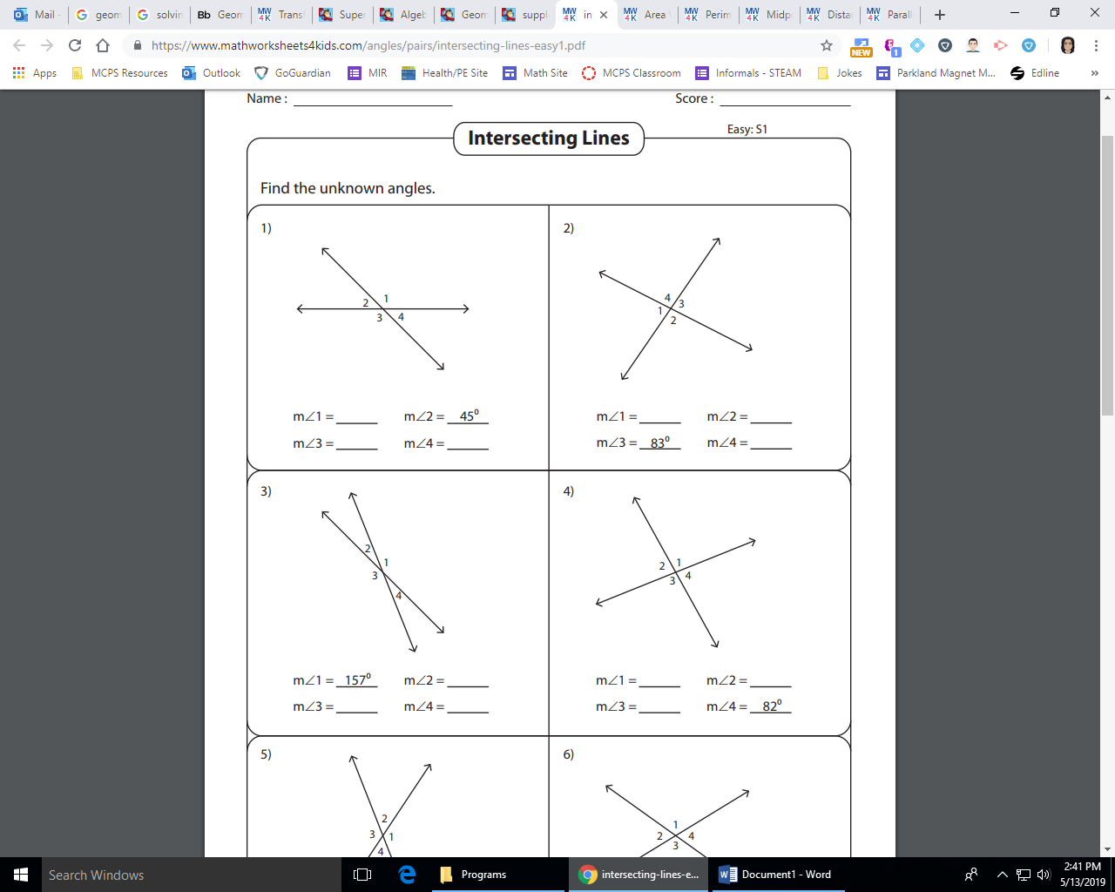

______________

17.)

19.)

18.)

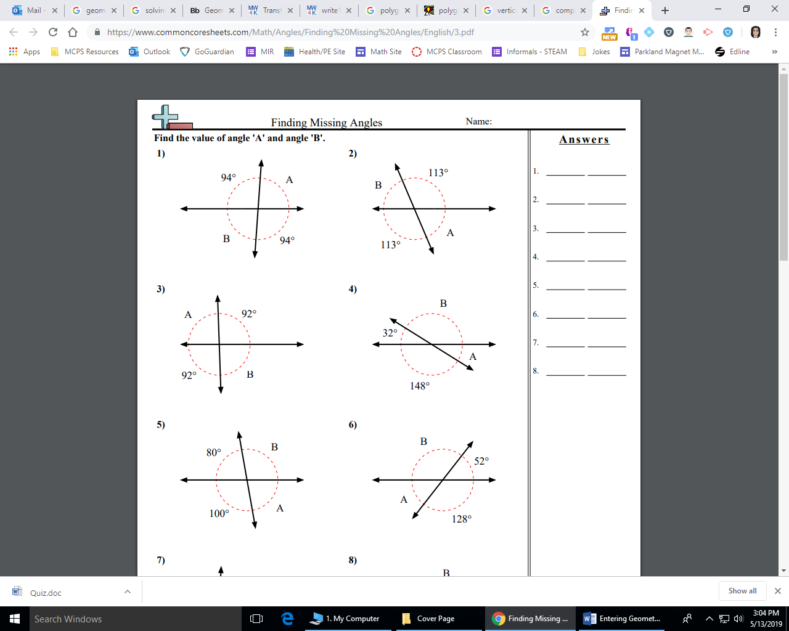

____________ ____________

21.)

20.)

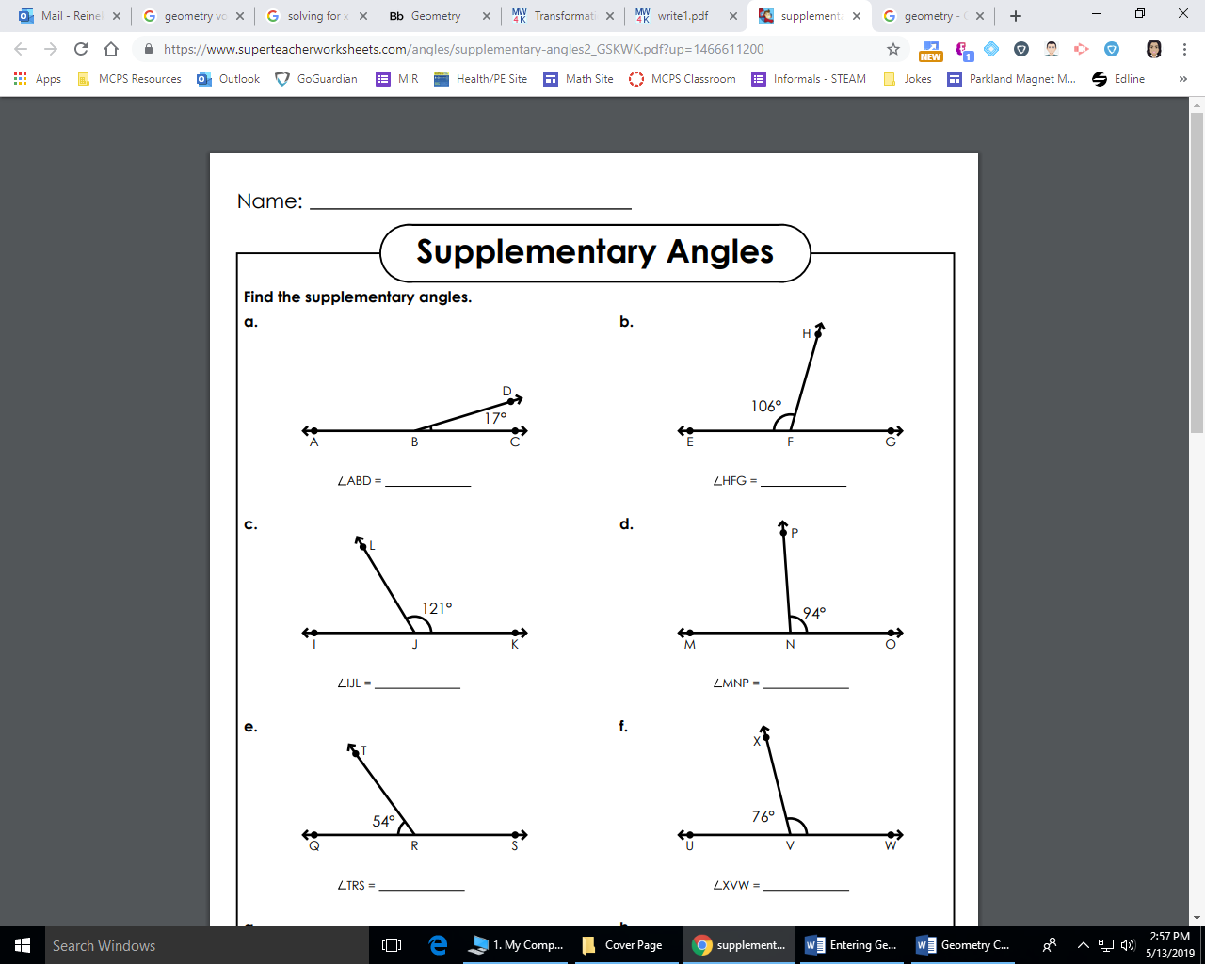

**Part III - Solving Equations Based on Properties of Shapes**

Solve for x and determine each of the side lengths.

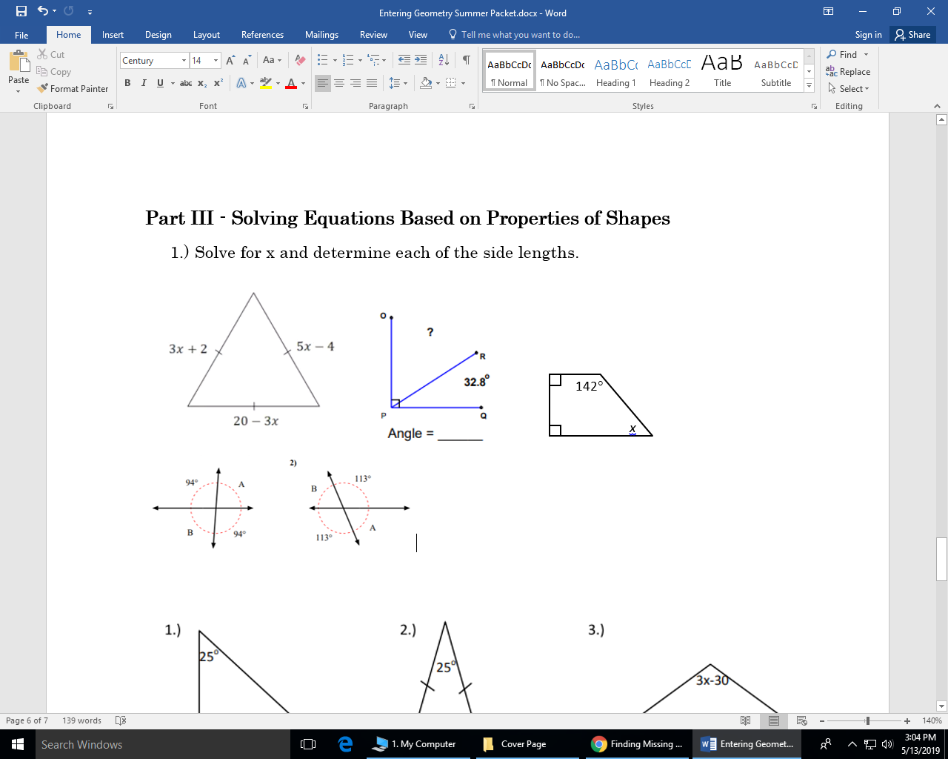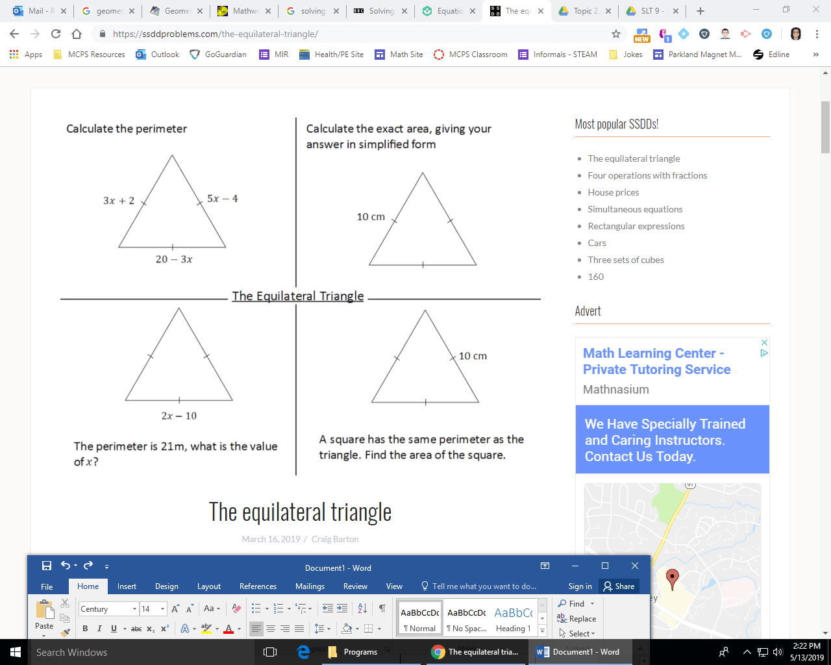

______________

______________

23.)

22.)

24.)

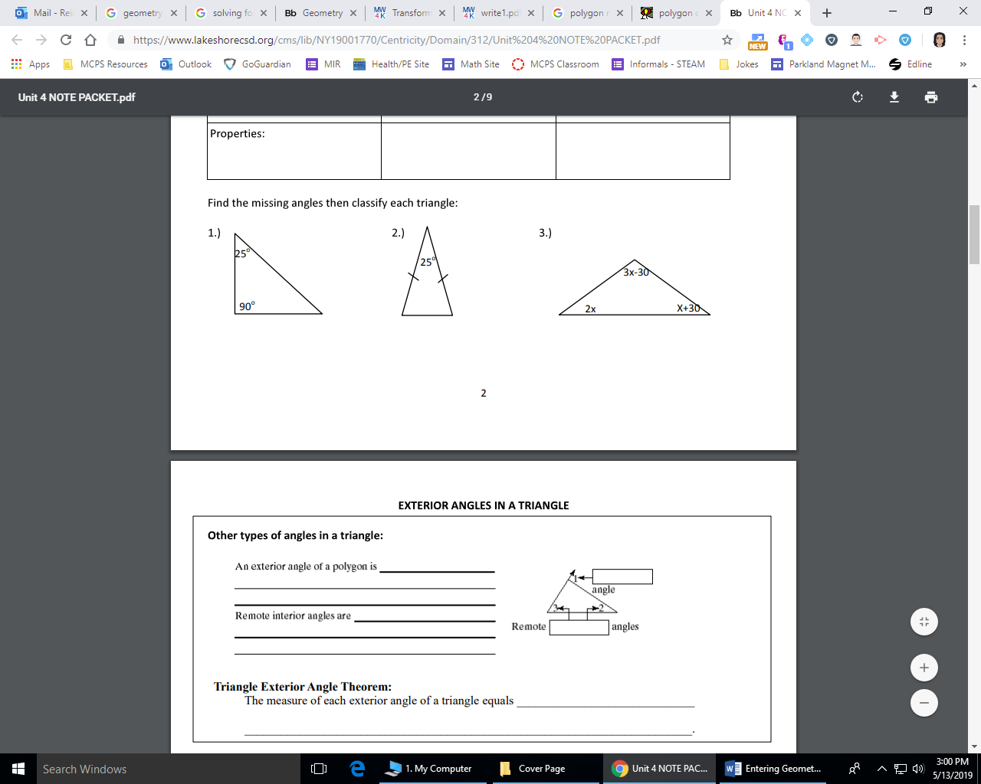

______________

______________

______________

26.)

25.)

**Part IV – Types of Transformations**

Label the type of transformation that exists between the two figures.

27.)

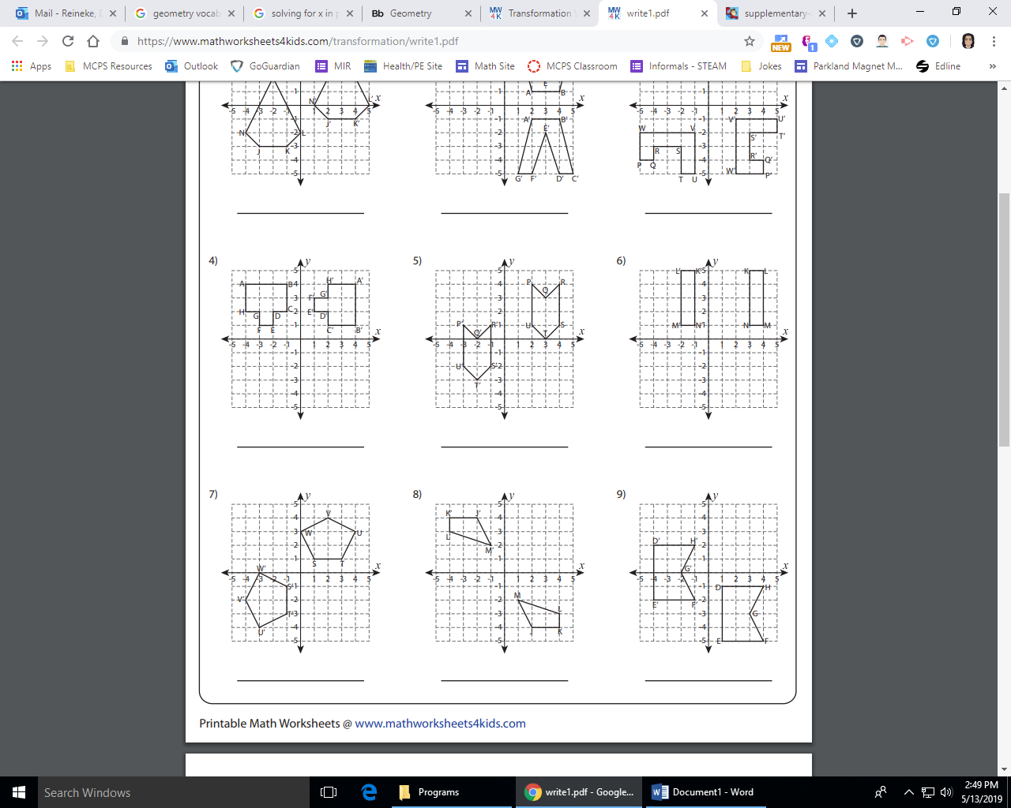

30.)

29.)

28.)



32.)

31.)