WHAT YOU NEED TO KNOW FOR:

ALGEBRA

Name: _______________

Due on the second Friday of the school year!
- Integer Operations
Resources: KhanAcademy.org - Adding numbers with different signs (video), Adding & subtracting negative numbers (video), Multiplying and dividing negative numbers (video)
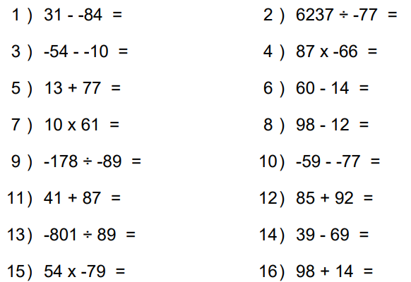
Apply the integer operation for each problem.

- Combining Like Terms
Resources: KhanAcademy.org - Distributive property over addition (video), Distributive property over subtraction (video), Combining like terms (video)
Combine like terms for each problem. Use the Distributive Property when required.
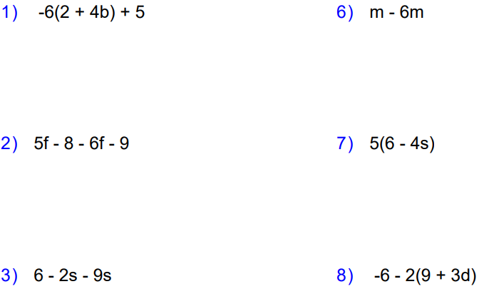

- Solving Equations
Resources: KhanAcademy.org – One-Step Addition Equations (video), One-Step Subtraction Equations (video), One-Step Multiplication Equations (video), One-Step Division Equations (video), Intro to two-step equations
Solve each equation.
$3x=18$ $\frac{x}{4}=-5$ $x-12=8$

$3x-9=18$ $\frac{x-2}{4}=-5$ $4x-12=8$

- Solving Inequalities
Resources: KhanAcademy.org – One-step inequalities examples (video), One-step inequalities: -5c ≤ 15 (video), One-step inequality involving addition (video)
Solve each inequality.
$2x≤-10$ $-\frac{x}{7}≥-2$ $x+15<10$

$2x-7<-10$ $\frac{x+7}{5}≤3$ $-4x+2≥26$

- Arithmetic and Geometric Sequences
Resources: KhanAcademy.org – Finding patterns in numbers (video)
Determine the pattern and complete each sequence
$2, 4, 6, 8, _____, _____, _____,$

$2, 4, 8, 16, _____, _____, _____,$

$10, 17, 24, 31, _____, _____, _____,$

$160, 80, 40, 20, _____, _____, _____,$

$1, 2, 4, 7, _____, _____, _____,$

- Writing Linear Expressions and Equations
Resources: KhanAcademy.org - Writing expressions word problems (video)
Write an expression or equation for each scenario.
A number multiplied by 6, then added by 8. __________________________
A number divided by 3, then subtracted by 11. __________________________
A number added by 3, then multiplied by negative 4. __________________________
A can company charges a $3.50 fee to call a cab and then charges $5 for every mile driven.

A customer paid $56 for a car ride. How far did the taxi drive, Write an equation and show your solution steps.
- Plotting Points
Resources: KhanAcademy.org – Plotting a point (ordered pair) (video)
Use the grid provided to complete the questions.
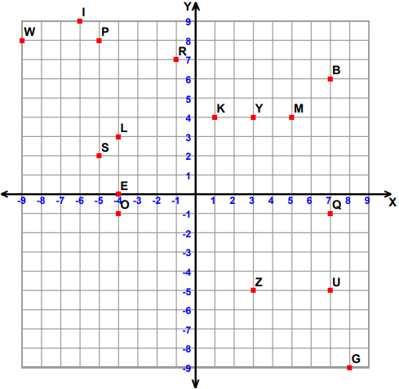
Write the point at each ordered pair.
(-6, 9) ______ (5, 4) ______ (1, 4) ______ (-5, 8) ______
(-4, 3) ______ (-5, 2) ______ (3, -5) ______ (-4, 0) ______

Write the ordered pair for each given point.
R ______ G ______ B ______ Y ______
O ______ Q ______ U ______ W ______

Plot the following points on the coordinate grid.
T (-9, 5) N (9, -4) H (-8, -6) V (-1, 3)
X (-9, -4) A (-9, 2) J (-2, 2) C (9, 0)

- Graphing Slope-Intercept Form
Resources: KhanAcademy.org – Graph from slope-intercept equation (video)
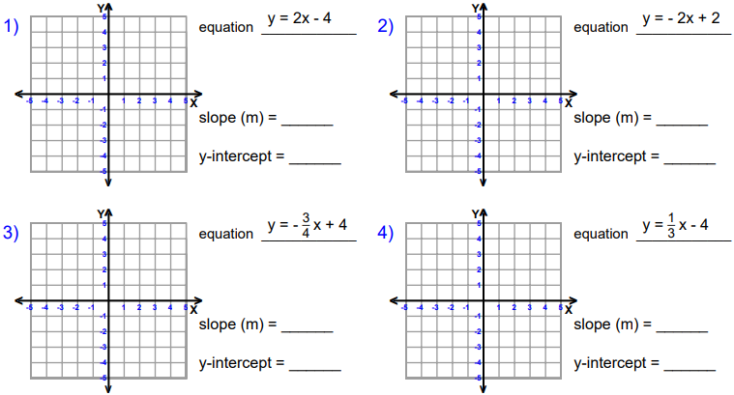
Plot the y-intercept and use the slope ( $\frac{rise}{run}$ ) to graph each line.

