John Poole Middle School
Summer Reading 2022

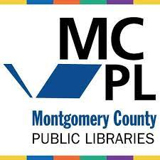

The goal of any summer reading program is to help motivate students to continue reading even while school is not in session. Recent studies have projected that students could lose as much as 39% of their literacy gains due to school closures and the normal “summer slide.” Furthermore, we know that providing students choice increases motivation and engagement and that rich resources exist at the newly renovated Maggie Nightingale library in Poolesville.

For summer 2022, students are encouraged to sign up for the Montgomery Public Library Summer Reading Challenge: Oceans of Possibilities. There is no separate program or requirement that is specific to John Poole. Simply sign up online starting June 15, read, complete activities offered online, and (hopefully) win prizes! If you or your child(ren) need a library card, find directions here: Digital Public Library Card.

