**French 2B / La Vie quotidienne**

**À la maison**

**Des maisons africaines**

**Directions:** After discussing the differences between modern houses and traditional houses, view the following web pages and write your observations about traditional homes in several African countries.

*Burkina Faso*

1. Where is it located?

2. What is the capital?

cid:image001.png@01CE2153.6650DA20

3. Go to <http://www.aae-ouaga.org/atravers.htm>and view traditional homes. Describe a traditional village.

cid:image001.png@01CE2153.6650DA20

cid:image001.png@01CE2153.6650DA20

cid:image001.png@01CE2153.6650DA20

4. Describe traditional homes.

cid:image001.png@01CE2153.6650DA20

cid:image001.png@01CE2153.6650DA20

5. What characteristics of the traditional homes do you like the most? Why?

cid:image001.png@01CE2153.6650DA20

*Benin*

1. Where is it located?

2. What is the capital?

MCPS FL INSTRUCTIONAL GUIDE 2004-05

At Home/*À la maison :* Cultural/Comparisons

Revised 8/4/05

95

**DRAFT**

cid:image001.png@01CE2153.6650DA20

3. Go to <http://www.aae-ouaga.org/Benin.html>and view traditional homes. Describe a traditional village.

cid:image001.png@01CE2153.6650DA20

cid:image001.png@01CE2153.6650DA20

cid:image001.png@01CE2153.6650DA20

4. Describe traditional homes.

cid:image001.png@01CE2153.6650DA20

cid:image001.png@01CE2153.6650DA20

5. What characteristics of the traditional homes do you like the most? Why?

cid:image001.png@01CE2153.6650DA20

*Mali*

1. Where is it located?

2. What is the capital?

cid:image001.png@01CE2153.6650DA20

cid:image001.png@01CE2153.6650DA20

3. Go to <http://www.aae-ouaga.org/mopti%20dogongs.html>and view traditional homes. Describe a traditional village.

cid:image001.png@01CE2153.6650DA20

cid:image001.png@01CE2153.6650DA20

4. Describe a traditional home.

cid:image001.png@01CE2153.6650DA20

cid:image001.png@01CE2153.6650DA20

4. Go to <http://www.aae-ouaga.org/djennmal.html>and describe the great mosque.

cid:image001.png@01CE2153.6650DA20

MCPS FL INSTRUCTIONAL GUIDE 2004-05

At Home/*À la maison :* Cultural/Comparisons

Revised 8/4/05

96

**DRAFT**

cid:image001.png@01CE2153.6650DA20

5. What characteristics of the traditional homes do you like the most? Why?

cid:image001.png@01CE2153.6650DA20

Compare and Contrast two traditional villages and houses in two different African countries using the Venn Diagram.

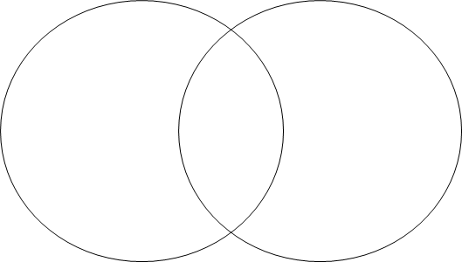

cid:image003.png@01CE2153.6650DA20

cid:image003.png@01CE2153.6650DA20

Name of Country:                                          Name of Country:

MCPS FL INSTRUCTIONAL GUIDE 2004-05

At Home/*À la maison :* Cultural/Comparisons

Revised 8/4/05

97