Biotechnology and Bioengineering
New Course for 2018-2019
- 11th and 12th grade advanced science elective
- Honors Credit
- No prerequisites
- Project-Based Learning approach
- Instructor: Ms. Chung
- Highly recommended for students in the Foundations of Biomedical Science program.

Explores how technology and engineering can used to address issues in health and biological sciences.
Human Factors Engineering  - Can you build a chair out of cardboard that is strong and comfortable? | 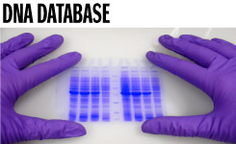  DNA and Protein Synthesis  - Who owns your DNA and what if they try to change it?
Treatment of Disease  - Can you design a mobile app that helps diagnose or treat diseases? | Bionics and Prosthetics  - Can you design a 3D printed hand and make it work?
Tentative topics. Final curriculum will be planned and approved during the summer of 2018.

