COURSE REGISTRATION INSTRUCTIONS
- Students should use the following URL: https://portal.mcpsmd.org/public/
- Enter your username (6 digit ID #) and password (the password you use to log into the computers at school), then select “Sign In”
- Once you have signed in you will see a navigation screen like the screen below:
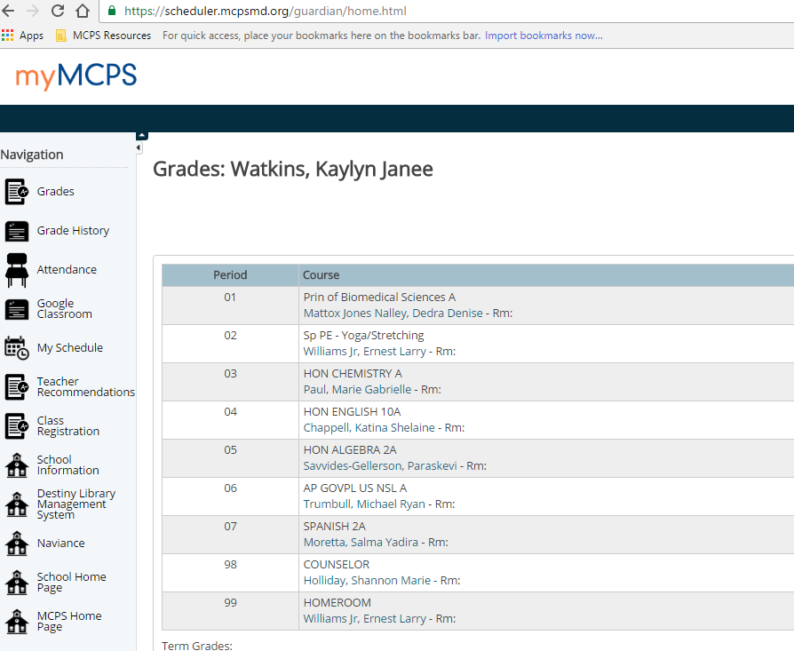
Student name
- To begin the registration process, click the “Class Registration” link to the left.
Student name
- On the next screen, you will find the class registration page for the upcoming school year.
  - On the page, there are several categories of classes from which you will select your courses for next year. **Remember to select enough classes to fill your schedule (7 classes)
- On the right hand side of the screen you will see two icons. The denotes the choice has been made, or that there is no choice required in that section. The denotes a selection still needs to be made.
- Begin by reading the instructions for each of the sections. Based on that information, you may need to select at least one course within that group. If not, simply move on to the next group.
  - To select courses in a group, click on the icon. A list of courses, and related teacher recommendations will appear on the screen
** Please note: some courses may have 2 or more pages of offerings.
*Teacher recommendations
**Some courses may have more offerings on different pages
- When finished, click “okay”
- Go through until you have finished selecting all of your courses
- Review your selections again and click “submit”
This completes your registration for the upcoming school year! If you have any questions, please see your counselor. If you are unable to complete registration, please come to the counseling office during lunch for further assistance!

