WATKINS MILL High School Counseling Office

10301 Apple Ridge Rd
Gaithersburg, MD 20879
301-284-4420
Watkins Mill High School Code: 210568

College Application Procedures

WATKINS MILL High School Counseling Office 301-284-4420

Dear Senior:

This year will be the busiest and most important year of your high school career. Make sure that you complete all necessary courses and earn the required student service learning hours to graduate on time. If you are not sure what the required number of SSL hours is for you, ask your counselor. Work hard and smart to achieve the best possible grades and avoid the temptation to cruise through second semester! What will you do after you leave Watkins Mill High School? Inside this packet you will find the information needed to apply to college or vocational schools. Please read each section carefully. We’re here to help along the way:

Your COUNSELOR:
- Ensures you have all necessary courses to graduate (You must earn the credits)
- Gives advice on researching & investigating post-secondary education or careers
- Provides information about potential schools that “suit you”
- Supports and advocates for you through letters of recommendation

The COLLEGE & CAREER INFORMATION COORDINATOR (Mrs. Heald):
- Provides research materials and programs (catalogs, books, websites, etc.)
- Offers assistance with college and career computer program searches
- Advertises college and local scholarship opportunities, as well as financial aid information
- Provides college testing materials & career assessment test information
- Posts a wealth of information on the Watkins Mill website regarding college & careers

The REGISTRAR (Mrs. Walker)
- Assists with processing application materials (both college & scholarship)
- Processes Secondary School Report Form (counselor recommendation) upon request
- Provides unofficial/official student transcripts and collects fees
- Maintains deadlines (15 school days required for processing)
- Sends mid-year and final transcripts to college(s) upon request

Additional Resources:
College Tracks: CollegeTracks is a program for juniors and seniors who need help with college access "know-how" and support to navigate the college admissions and financial aid process. College Tracks is located in room A006.

ACES: Achieving Collegiate Excellence and Success (ACES) is a collaborative effort between Montgomery College, Montgomery County Public Schools, and the Universities at Shady Grove to support select students at Watkins Mill and provide a seamless path to a bachelor's degree. ACES is located in room E107.

Best wishes for a successful school year!

The Watkins Mill High School Counseling Office

Watkins Mill High School Code: 210568

COLLEGE ADMISSION GLOSSARY

EARLY DECISION: A binding agreement in which a student applies in October or November, learns if they are accepted in December or January, and is obligated to matriculate to that college. This is suggested only for students who are academically very strong, know positively which college they want to attend, regardless of the cost to attend.

EARLY ACTION: This differs from early decision in that students are not required to accept admission or withdraw other applications if accepted by the college early. Students may apply to more than one college early action.*

PRIORITY or Early Notification: A program in which a student files his application before the regular decision deadline, usually by November 1, in order to receive an admission decision by early February. Students have until May 1 to decide whether or not they will attend the college.*

ROLLING ADMISSION: A program in which applications are evaluated upon receipt and applicants are notified quickly of the admission decision (usually within 3-4 weeks). Applications are considered until spaces are filled. Submitting your college application early is encouraged.

REGULAR ADMISSION: A program used by most schools. Typically, January 1st is the deadline for applications and the student is notified before the first week of April.

OPEN ADMISSION: Most community colleges offer open admission. All students who apply are accepted, but must take a placement test prior to scheduling classes. The test scores are used for college course placement purposes.

*Many colleges accept the majority of their applicants by the early action, priority or early notification deadlines. Early action or priority deadlines are encouraged for students who hope to be considered for merit scholarships awarded by colleges. Be sure to check with each college to determine if there are separate applications to be completed for scholarship consideration.

ADHERE TO ALL DEADLINES!

College Planning Check list

Fall
___Narrow your list of colleges to between five and 10. Meet with your counselor about your college choices and, if you’ve not yet done so, download financial aid forms and determine whether your schools are part of the Common Application, the Coalition Application, or if you will need to download their application. Plan to visit as many of these colleges as possible.
___Create a master list or calendar that includes:
- Tests you’ll take and their fees, dates and registration deadlines
- College application due dates
- Required financial aid application forms and their deadlines (aid applications may be due before college applications.)
- Other materials you will need (recommendations, transcripts, etc.)
- Your high school’s application processing deadlines
___Fill out your Brag Sheet (can pick up in counseling office)
___Ask your counselor to help you request a fee waiver if you can’t afford application or test fees
___Take the ACT or SAT one more time: Many seniors retake one of these tests in the fall. Additional course work since your last test could help you boost your performance.
___Be sure to have your SAT/ACT scores sent to the colleges to which you are applying.
___Complete the Free Application for Federal Student Aid (FAFSA). To apply for most financial aid you’ll need to complete the FAFSA. October 1 is the first day you can file the FAFSA.
___Complete the CSS/Financial Aid PROFILE® if necessary: Profile is an online application used by certain colleges and scholarship programs to determine eligibility for their aid dollars.
___Prepare early decision/early action or rolling admission applications as soon as possible. Nov. 1-15: Colleges may require test scores and applications between these dates for early decision admission.
___Ask a counselor and/or teacher for recommendations if you need them. Give each teacher or counselor a copy of your student brag sheet.
___Write first drafts and ask teachers and others to read them if you’re submitting essays. If you’re applying for early decision, finish the essays for that application now.
___Fill out the Transcript requests forms and return to Ms. Barr or your counselor.

Spring
___If you are waitlisted, the college will want to know what you have accomplished between the time you applied and the time you learned of its decision.
___Visit your final college, if possible, before accepting. You should receive acceptance letters and
financial aid offers by mid-April. Notify your counselor of your choice. If you have questions about
housing offers, talk to your college counselor or advisor.
___Inform every college of your acceptance or rejection of the offer and/or financial aid by May 1.
Colleges cannot require your deposit or your commitment to attend before May 1. Talk to your
Counselor or advisor if you have questions.
___Send your deposit to one college only.
___Take an AP exams. Show what you’ve learned in your AP classes. A successful score could even
earn you credit, advanced, or both in college.
___Waitlisted by a college? If you intend to enroll if you are accepted, tell the admission director your
intent and ask how to strengthen your application. Need financial aid? Ask whether funds will be
available if you’re accepted.
___Work with your counselor to resolve any admission financial aid problems.
HOW TO APPLY TO COLLEGE

Should I use the Common Application, the Universal Application, a college specific application, or the new Coalition Application? Ultimately, the answer for this question depends on which colleges you choose to apply to. Most (but not all) colleges accept the Common Application, whereas the new Coalition Application is not yet embraced by a majority of schools. The new Coalition Application does, however, encourage you to begin charting your high school achievements early and may give your college applications a more detailed, humanized picture of you as an applicant. As long as they offer those options, colleges do not penalize you for submitting the Common Application or the Coalition Application over their own version. However, be advised that state schools generally have their own application that they will require you to use. Your best bet is to check on a college’s website or to contact the admissions office to find out what each specific college accepts.

_____Complete & submit admission application online to each desired college. Read the directions carefully to learn what should be sent along with the application and adhere to all application deadlines. (Make a copy of the completed application!)

_____Pay the application fee or submit a college application fee waiver. (Students who received an SAT or ACT fee waiver are eligible for up to 4 college application fee waivers).

_____Request your Official Transcript & Counselor Recommendation Please allow the Watkins Mill Counseling Office 15 school days to prepare recommendations and secondary school reports. Bring the following to Mrs. Walker in the Counseling Office:

- Completed “Student Brag Sheet”
- Completed and Signed Transcript/Information Release Form (attached).
- For schools that do not accept electronic delivery, a 9”x12” envelope addressed to each college with 3 first class stamps. Mrs. Walker will stamp it with the Watkins Mill HS address stamp, so DO NOT put your return address on the envelope.
- Completed WMHS Secondary School/Counselor Report (attached)
- Let Mrs. Walker know if a counselor recommendation letter is needed.
- Pay transcript fee: 1-3 transcripts (free), 4 or more ($3.00 per each additional transcript).

_____ Send ACT scores (www.actstudent.org) and SAT scores (www.collegeboard.org) directly from the website to your colleges.

_____Request Teacher Recommendations in person to 2 teachers using the “Request for Recommendation Letter” form (attached). Provide a stamped, addressed business envelope (4x9) to the teacher for schools that do not accept electronic delivery.

_____If any of your colleges require a Mid-Year School Report By February 15th, ask Mrs. Walker to submit your senior midyear report (transcript) to each school that requires it and submit one stamped envelope (business size 4x9) addressed to the college for each Mid-Year School transcript needed for schools that do not accept electronic delivery. There is no fee for requesting mid-year reports.

_____Request Final Transcript

_____ Complete the Senior Survey on Naviance/Family Connection (in the “About Me” tab), https://connection.naviance.com/family-connection/auth/login/?hsid=wmhs , to indicate where the final transcript should be sent. No fee or envelope is necessary. Final transcripts will be sent by the Registrar, in mid-July.

eDocs

• What is eDocs? eDocs is an electronic college application tool, allowing WMHS to prepare and send college application documentation electronically.

• What does this mean for the student? If any of your colleges accept transcripts and documentation electronically, the student does not need to submit envelopes to Mrs. Walker.

• What does the student need to do?
- Create an account at www.commonapp.org.
- Complete the FERPA waiver found on the Common App under “Assign Recommenders” on the “My Colleges” tab.
- Make sure all of your common app schools are listed in the “My Colleges” section at www.commonapp.org
- Log into Naviance/Family Connection and enter your Common App email address under “Colleges I’m Applying To” and click “Match.”
- Please note that if the common app is not completed for a common app school as indicated by on Naviance/Family Connection, then the student must provide a 9 x 12 envelope and 3 stamps so that the documents can be mailed to the college.
- For a list of schools who use the Coalition App visit: http://www.coalitionforcollegeaccess.org/
- For Coalition App schools create and account using the link provided above and click on create account.

• How do you know which schools accept electronic documents?

Family Connection shows three different icons for “submissions”:
a) A computer screen means the college accepts documents electronically.

b) A computer with a “CA” means the student must complete the Common Application, www.commonapp.org, in order for documents to be sent electronically.

c) A postage stamp means the student must give Mrs. Walker a stamped addressed manila envelope for documents to be sent.

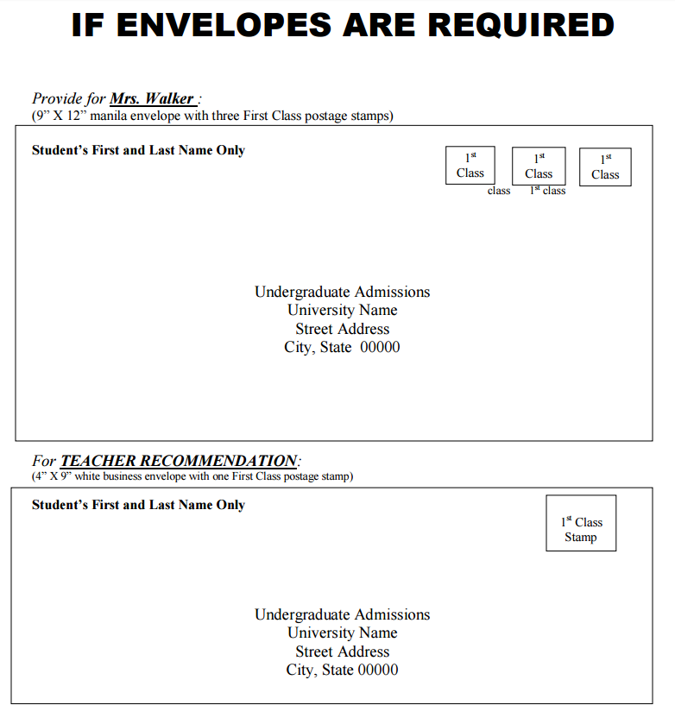

Students may want to write their name under the flap of the envelope.

Directions: Complete & return to School Counseling Office before the first week in October.
Student Brag Sheet
FOR COLLEGE AND SCHOLARSHIP RECOMMENDATIONS

Name: ____________________________________________ Email: ______________________________

It is important that you answer all of the following questions thoroughly. The more information that you provide, the more complete your school recommendation will be.

Circle three words that best describe you:
hardworking | moral | determined | positive | focused | humorous
optimistic | analytical | organized | responsible | visionary | animated
mature | flexible | imaginative | goal-oriented | active | ingenious
witty | dedicated | executive-caliber | multitalented | ambitious | intelligent
meticulous | original | independent | professional | motivated | amiable
well-educated | athletic | detail-oriented | honest | creative

Describe your strengths, interests, and talents. How have they influenced your life outside of school and your career/educational plans for the future? How do you plan to develop them further within the school or job you are seeking? ____________________________________________________________________________________________________________________________________________________________________________________________________________________________________________________________________________________________________________________________________________________________________________________________
What experiences or people have had the greatest impact upon the development of your career/educational plans? What has the impact been? ____________________________________________________________________________________________________________________________________________________________________________________________________________________________________________________________________________________________________________________________________________________________________________________________

Are there any special factors or situations that a college should know in evaluating your high school career? Have you had to overcome any obstacles or setbacks? If not, describe your most rewarding experience during high school (academic, extra-curricular, or personal). ____________________________________________________________________________________________________________________________________________________________________________________________________________________________________________________________________________________________________________________________________________________________________________________________

Have there been any unique issues which may have affected your school performance? What did you learn that will prepare you for college? ____________________________________________________________________________________________________________________________________________________________________________________________________________________________________________________________________________________________________________________________________________________________________________________________

Did your parents attend college? If so, where? Will you be the first in your family to graduate from college?

______________________________________________________________________________________________
School Activities | Grade(s) | Office Held

Athletics | Grade(s) | Years JV | Years Varsity | Years Captain | Special Recognition

Of all your activities inside and outside of school, which has been the most important to you? Why? ____________________________________________________________________________________________________________________________________________________________________________________________________________________________________________________________________________________________________________________________________________________________________________________________

In what other significant ways have you spent your time away from school (evenings, weekends, and summers) and how have these activities contributed to your development? ____________________________________________________________________________________________________________________________________________________________________________________________________________________________________________________________________________________________________________________________________________________________________________________________

List any honors or awards you have received in or out of school. ____________________________________________________________________________________________________________________________________________________________________________________________________________________________________________________________________________________________________________________________________________________________________________________________

What would you most like to have recognized as a school or employer considers your application? _____________________________________________________________________________________________________________________________________________________________________________________________________________________________________________________________________________________________

SUBJECTS INTERESTED IN STUDYING DURING COLLEGE:
________________________________________________________________________________________________________________________________________________________________________________________________

CAREER CHOICE: _________________________________________________________________________________
Watkins Mill High School

REQUEST FOR RECOMMENDATION LETTER
[Hand Deliver to Teachers]

DATE: _____________________________

TO: _______________________________________________________
TEACHER
FROM: _______________________________________________________
STUDENT

Student: It is your responsibility to request letters of recommendation & follow up with each teacher to ensure that deadlines are met. Please give teachers advance notice (15 school days). Along with this recommendation request form, provide the teacher with a stamped addressed envelope for each letter requested for “mail” schools.

Teacher: Please complete your recommendation letter on school letterhead and either upload it to Family Connection or place it in the stamped, addressed envelope provided by the student for “mail” schools. If the recommendation letter must accompany a scholarship application, place your recommendation letter in a Watkins Mill HS envelope marked CONFIDENTIAL, seal it and return it to the counseling office for mailing. [Please save copies of all recommendations for future reference.]
Name of College or Scholarship | DEADLINE DATE | Special Instructions
Information needed to write a recommendation letter: (student completes)
Student’s cumulative GPA: __________ __________ (Obtain GPA from transcript) unweighted weighted
- Anything special to be emphasized in the recommendation letter? (examples: financial need,
Non-native, first in immediate family to attend college, talents, special honors/awards, leadership roles, etc.)
___________________________________________________________________________________________________________________________________________________________________________________________________________________________________________________________________________

- Extracurricular activities (both in & out of school - athletics, jobs, internships, community service): ___________________________________________________________________________________________________________________________________________________________________________________________________________________________________________________________________________

- What did you get out of this teacher’s class? ___________________________________________________________________________________________________________________________________________________________________________________________________________________________________________________________________________

WATKINS MILL HIGH SCHOOL
Secondary School Report Form
Instructions: Students should complete and sign Section I and submit the form to the Registrar’s Office.

Counselors will complete Section II and forward the report form along with the transcript to each school to which the student is applying.

SECTION I (to be completed by student)

Student Name ______________________________________________________S.S. Number _______–_______–_______
Last First MI

Address ______________________________________________ _________________________ ________ _________
Street City State Zip Code

Date of Birth _______/_______/_________ Phone _____________________________

Email Address _____________________________________________________Student ID_________________________

I recognize the confidential nature of this document and I waive my right to access.

Student’s Signature _________________________________________ Date _______________________________

SECTION II (to be completed by school counselor)

High School: Watkins Mill High School High School CEEB: 210568

Address: 10301 Apple Ridge Road Gaithersburg, Maryland 20879 Phone: (301) 284-4420 Fax: (301) 840-3974

Counselor’s Name: __________________________________________________________ Title: School Counselor

Percentage of class attending: Four-Year 36% Two-Year 64% institutions.

Grading scale: 4.0 Passing grade is: D Student’s Unweighted GPA: __________ Student’s Weighted GPA___________

GPA includes: 9th grade, 10th grade, 11th grade and ____12th Grade (check if GPA includes 12th grade)

We do not rank our students by class

The student’s course selection is (check one): __Most Demanding __ Demanding __ Average __ Below Average

Distribution of Cumulative Grade Point Averages found on School Profile

Senior Year Courses: Indicated on transcript

WATKINS MILL HIGH SCHOOL COUNSELING DEPARTMENT
TRANSCRIPT & COUNSELOR RECOMMENDATION RELEASE FORM 2017-2018

List below the names of the colleges/universities to which you are applying. You are to provide addressed envelopes with postage (manila envelope – 3 stamps) for schools that DO NOT accept electronic delivery.

Allow 15 school days to process transcripts with counselor recommendation letters. Please be aware that failure to submit transcript/recommendation requests in a timely manner may result in deadlines not being met.

Student’s Name: __________________________________ ID#:___________Counselor:____________________________

Address: ___________________________________ Phone #:_________________email:___________________________

I give WMHS staff permission to release transcripts to individuals and/or institutions listed below and to answer all questions directed to school officials that may appear on any application materials submitted to accompany a transcript for the above named student.

_______________________________________________________ __________/___________/201_____
Parent/Guardian Signature Date
Name of College or University | Did you use? Common App,Coalition App, University App | Is Letter of Recommendation Needed?  Yes or No | *Does Transcript need to be mailed? Provide 9X12 stamped and addressed envelope for “mail schools for which you did not use Common or Coalition App  Yes or No | Fee | Counseling Office Use Only
1. |  |  |  | FREE
2. |  |  |  | FREE
3. |  |  |  | FREE
4.
5.
6.
7.
8.
9.
10.
11.
12.
13.
14.
15.

*Did you include a 9X12 self- addressed and stamped envelope (3 first class stamps) for each of the Colleges or Universities for which you are requiring transcripts to be sent?

