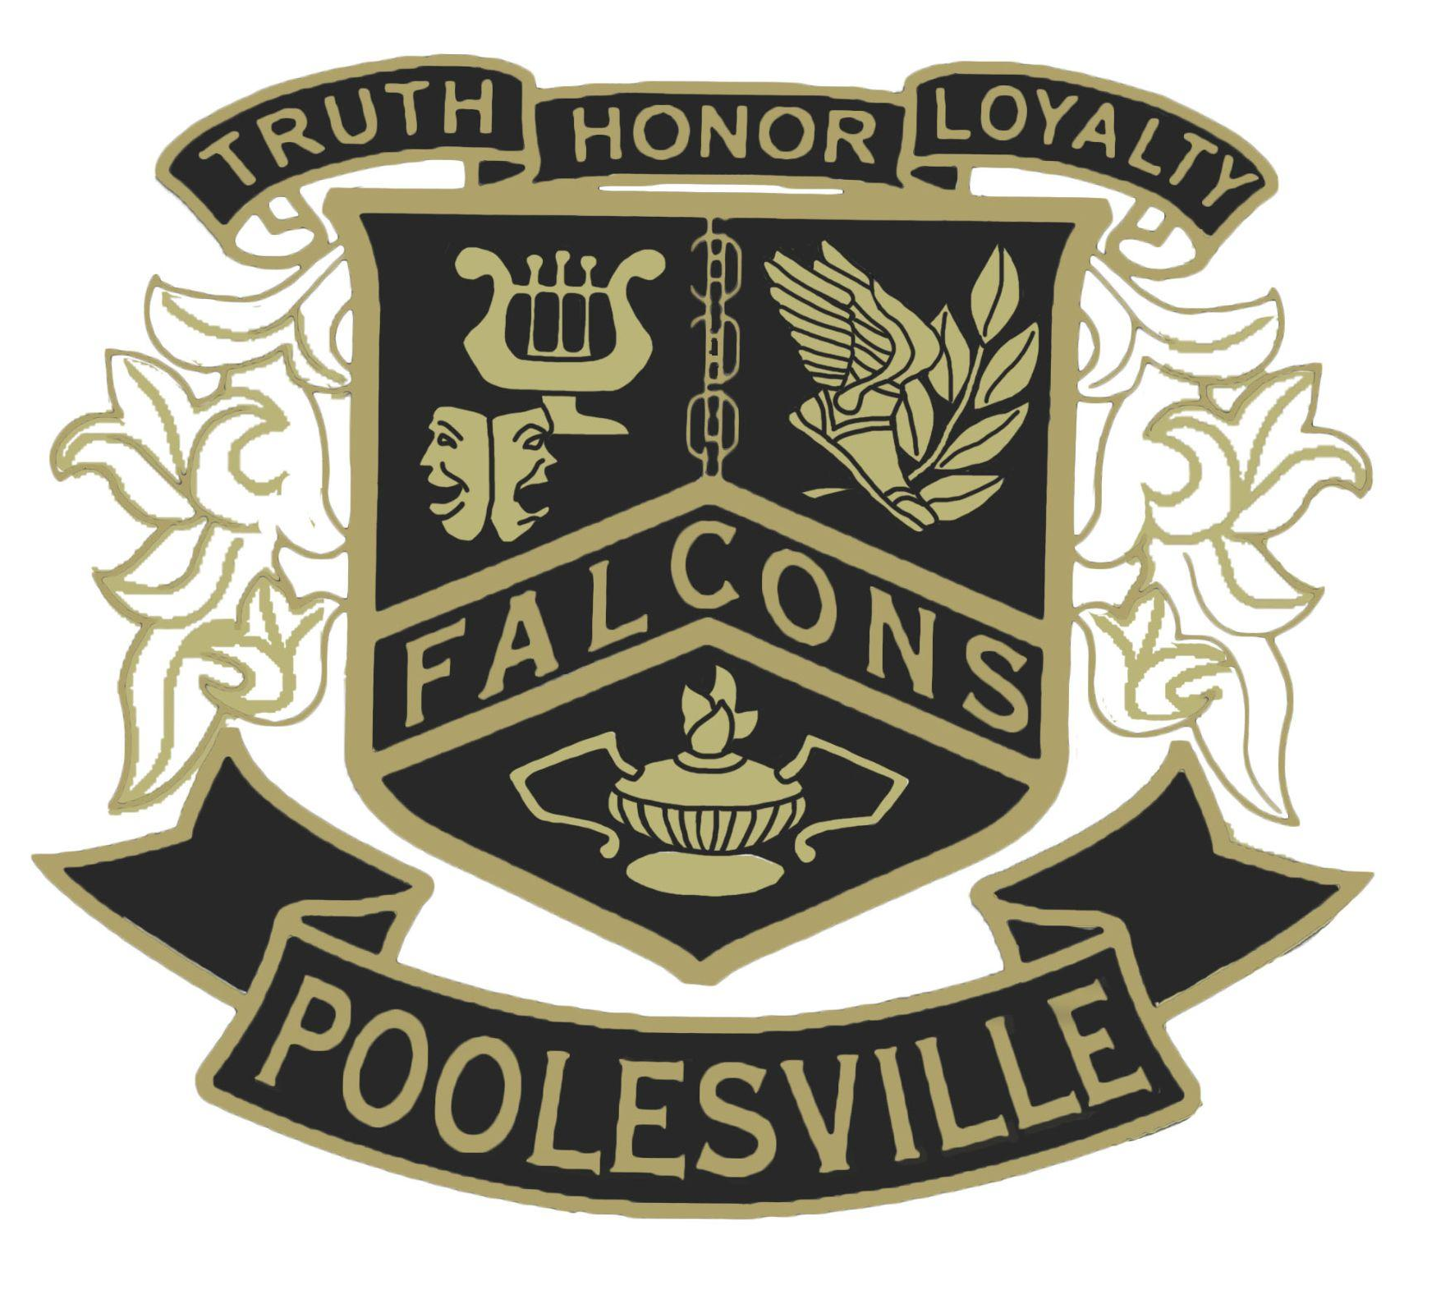

Poolesville High School Student Expectations

Poolesville High School is a community of scholars who should conduct themselves in a manner demonstrating respect for self and others at all times. This document highlights important behavioral expectations. The current edition of A Student’s Guide to Rights and Responsibilities in MCPS provides greater detail and a wider range of expectations. It can be accessed through the PHS and MCPS websites.

A Culture of Respect
Poolesville High School does not tolerate acts of hate or violence, bullying, discrimination, disruptive behavior, insubordination, profanity, sexual harassment, threats, or verbal abuse. All members of our school community must be treated with respect and consideration. Cooperation and appropriate behavior is expected of all students while participating in both classroom and non-classroom activities, while being transported in MCPS vehicles, and while attending school or MCPS events.

General Rules
Academic Dishonesty Academic dishonesty (including plagiarism) on any type of assigned work may result in a zero for the work and parents may be contacted. Academic dishonesty may result in removal from leadership positions and/or additional interventions.
Attire Clothing will not contain drug or alcohol references, hateful (swastika, confederate flag, etc.) or obscene (profanity, vulgar images, etc.) messages, or threaten violence. Masks must also be worn at all times when in the building. Students dressed inappropriately will meet with an administrator and will change into appropriate attire. Parents may be contacted.
Electronic Devices During class time, cell phones and headphones are not permitted. Students will receive a verbal warning for the first violation; administrative intervention may occur with subsequent violations. Teachers will complete a referral and contact home that day.
Language Language is expected to be courteous and respectful always. Use of inappropriate and hateful language may result in detention, administrative intervention, and/or parent contact.
Obligations Financial obligations must be reconciled prior to purchasing parking permits and tickets to events such as prom. Seniors must clear all obligations prior to graduation.
Open Lunch Open lunch is an opportunity to work with teachers and become involved in clubs and other extracurricular activities. Students leaving campus must return to school on time. Upperclassmen will not transport ninth and tenth graders, except family, in cars during lunch. Violations will result in administrative action and may result in loss of privileges.
Parking Students must apply for and purchase a parking permit and park only in designated student parking areas. Students must also attend a safety presentation prior to parking on campus. Violators may lose parking privileges.
Passes Students are expected to remain in class during the entire instructional period. Teachers may issue written passes to students. Failure to have a pass may result in detention, administrative action, and/or parent contact.

The staff of Poolesville High School want you to be successful and maintain high expectations for good attendance, exemplary behavior, and outstanding academic achievement.

