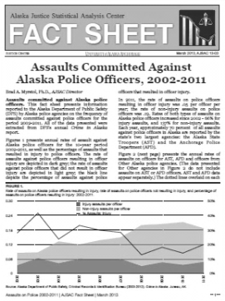
MWHH
Nations Fact Sheet Project
1945-the Present

Objective: Each student /pair of students will create a fact sheet that details the evolution of their assigned nation from its conditions during the Cold War to the present day. This fact sheet must include the following information in the formats noted:
- A brief narrative history of the country from 1945 to the present. (3-5 paragraphs)
- A physical map showing the geography of the country; if changes were made in the period under study (i.e. boundary changes, etc.) please provide maps for each change
- A brief summary of the political systems under which the country was ruled during this period
- A timeline of the major political events and rulers from 1945 to the present; this should be broken into 5 year increments (e.g. 1945----1950----1955…)
- A list of the natural resources found within the country’s borders as well as a map that shows where these resources are found.
- A brief summary of the religion(s) that influence/have influenced the country; if there is no formal religion, summarize the reasons why and what stood in its place.
- A list of the major industries of the nation as well as a list of its major exports and imports
- A line or bar graph (see http://www.typesofgraphs.com/bar.html for explanations if needed)that charts the country’s economic progress from 1945 through 2012; the measure you will use is the Gross Domestic Product per capita. All individuals/groups will also graph the GDP per capita for the United States
  - You must include a brief (1 paragraph) comparison of “your” country’s present-day data to that of same timeframe of the United States.

Points: 100
Due Date/Deadline: May 13, 2013

