COLONEL MAGRUDER HIGH SCHOOL PHYSICAL EDUCATION UNIFORMS 2017
Important!
- This store opens on September 5th and closes on September 15th at 11:59pm.
- All goods will be delivered to the school after production and will be distributed by the PE department.
- Size charts are available for each item.
-All sales are final.
Thanks for shopping with us!

You can now purchase your items online in 3 easy steps:
- Go to the online store at https://colmagruderhighschool.itemorder.com
- Choose your items and add them to your cart
- Securely checkout with your credit card
Online Store Deadline: Friday, September 15th, 2017 (11:59pm EST)

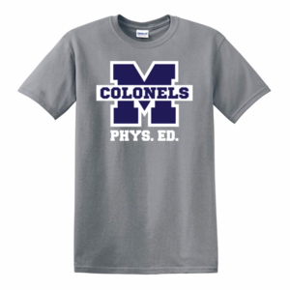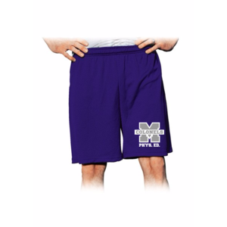
Gildan 100% Gravel Grey cotton t-shirt $10.00 Ramco Closed Mesh Short 7” $13.50

