Child Development Preschool
Magruder High School
5939 Muncaster Mill Road
Rockville, MD 20855
240-740-5511

Thank you for your interest in the Magruder High School Child Development Preschool. This unique program provides a quality educational experience for 4-year-old children and high school student teachers who are eager to work together.

Please read the information below. If you are interested in having your child attend our program, please complete the 2-page application and return it as directed on the form. You will be contacted upon receipt of the completed application and non-refundable registration fee, which is applied to the cost of the fall semester.

Medical forms and other pertinent information will be emailed to all enrolled families in early September. There will be an orientation in early October.

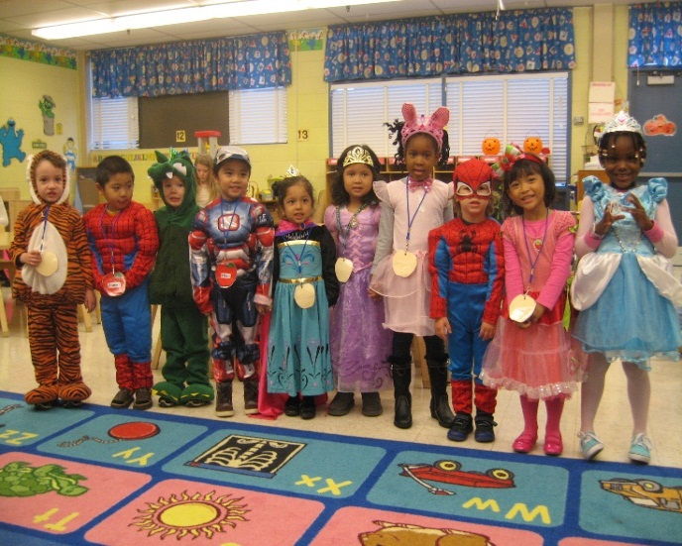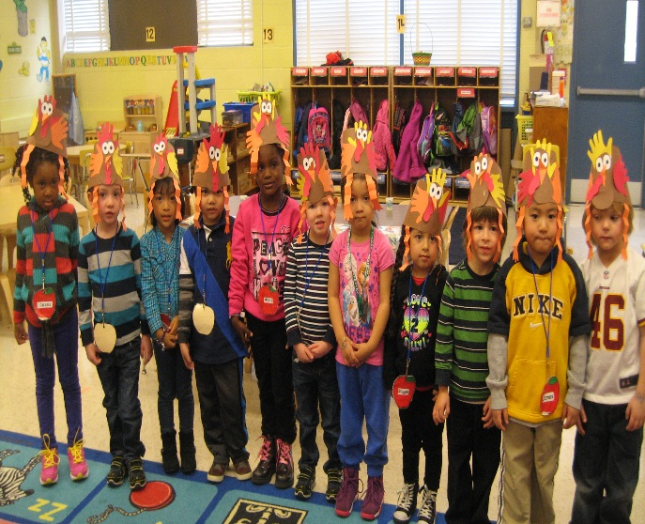

FREQUENTLY ASKED QUESTIONS

Listed below are answers to some of the most frequently asked questions about Magruder’s Child Development preschool program. If you have further questions, please contact me by phone 240-740-5511 or email Cheryl_L_Dembroski@mcpsmd.org.

Q: What is the preschool calendar?
We begin our program in mid-October and continue through late May. Schedules are adjusted to the Montgomery County Public School calendar and the needs of Magruder High School; final dates will be sent to you in early September. The first semester typically runs October – January, and the second semester typically runs February – May. Children are expected to attend both semesters, giving the Magruder students enrolled in our classes the opportunity to observe and document growth and development over the entire year.

Q: How often are preschool classes held?
Typically four days a week, Monday through Thursday. Fridays are reserved as the seminar day for the high school students so preschool students do not attend.
The schedule is subject to occasional changes, based on the needs of Magruder High School.

Q: What time does preschool meet?
Preschool meets from 7:50-11:05am

Q: What is the cost of the program?
$300 per semester. A non-refundable registration fee of $100 must be sent with the application. This fee will be applied to the first semester tuition. The balance for the first semester is due in October when the preschool begins. The second semester payment is due when the second semester begins.

Q: What are the age requirements?
The program is designed for children the year before they enter kindergarten, typically four and five years old. On occasion older three-year-olds are accepted if space allows.

Q: How many preschoolers in the class?
We accept 15 children.

Q: Who are the teachers?
High school students being trained and supervised by the MCPS Child Development/Family and Consumer Sciences (FACS) instructor.

Q: What do the children learn?
We are a play-based program that emphasizes the child’s physical, intellectual, emotional, and social growth and development, as well as the expected pre-kindergarten skills, such as counting, letter recognition, fine motor, and oral language.

Q: What would be included in a typical day?
The schedule includes whole group circle time activities (music, games, stories), small group instruction based on themes (language arts, math, science, art), outdoor or gym play, a nutritional snack (provided), and free play in centers (blocks, dramatic play, puzzles, manipulatives).

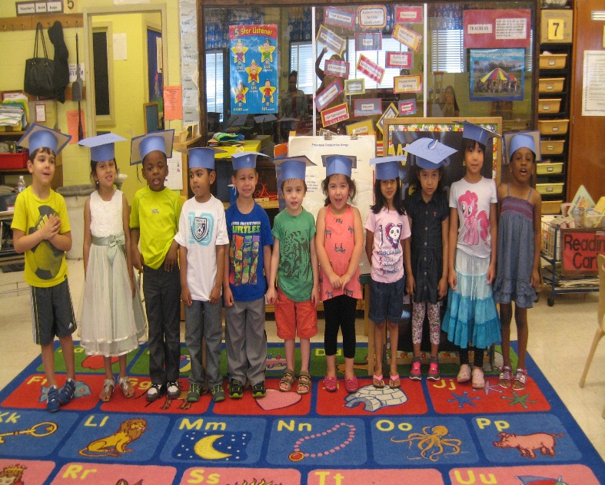

OFFICE USE ONLY
Date of Application_______________
Deposit________________________
Fall Balance_____________________
Spring Balance___________________

MAGRUDER CHILD DEVELOPMENT PRESCHOOL APPLICATION

Child’s name _______________________________________________________
Last First Middle
Prefers to be called ___________________________

Birth date_______________________ Age on 9/1/19 ________________

Address____________________________________________________________
Street City State Zip code

Home phone_______________________ Email___________________________

Parent name_______________________________________________________

Work phone__________________________ Cell phone_____________________

Email Address __________________________________

Primary Contact? Yes_____ No______

Parent name_____________________________________________________

Work phone__________________________ Cell phone_____________________

Email Address ____________________________________

Primary Contact? Yes_____ No______

Previous school experiences___________________________________________
__________________________________________________________________
Dietary restrictions or food allergies. Is medication required?
- _____________________ Yes _______ No______

- _____________________ Yes _______ No______

- ____________________ Yes _______ No______

- ____________________ Yes _______ No______

Important health information__________________________________________
__________________________________________________________________

My child does/ does not (circle one) have either an Individual Family Service Plan (IFSP) or an Individual Education Plan (IEP).

Please return this application with a $100 non-refundable registration fee (payable to Magruder High School) by mail or in person to
Magruder High School
5939 Muncaster Mill Road
Rockville, MD 20855
Attn: Cheryl Dembroski, Early Childhood Development

Application Process is open now and will close when class space is filled. Applicants are accepted on a first come-first serve basis.
MCPS prohibits illegal discrimination on the basis of race, color, gender, religion, ancestry, national origin, marital status, socioeconomic status, age, disability, physical characteristics, or sexual orientation. Inquiries or complaints regarding discrimination or Title IX issues such as gender equity and sexual harassment should be directed to the Office of the Deputy Superintendent of Schools at 301-279-3126, via the Maryland Relay at 1-800-735-2258, or addressed to that office at 850 Hungerford Drive, Room 129, Rockville, MD 20850.

