Philip Merrill Presidential Scholars Recipient – Sarahann Yeh – Class of 2012
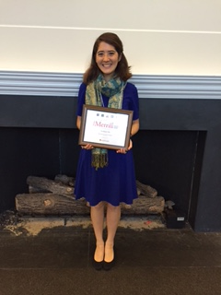
Sarahann Yeh is a senior at the University of MD College Park, studying Biological Sciences and International Development with a keen interest in global public health, human rights, and science diplomacy. When Sarahann Yeh was just a sophomore biological sciences major at UMD College Park, she was selected as one of fifteen recipients of the Fund for Education Abroad Scholarship. Selected from more than 1,000 applicants, she has been awarded $5,000 to study at East China Normal University at the CIEE Accelerated Chinese Language program. There she built foundational language skills to support a career in global public health focused in East and Southeast Asia. While abroad, Sarahann was been able to interact with the local community on a daily basis, and served as a biweekly volunteer at a nearby elderly center as well as a volunteer at ECNU's English corner. Sarahann was previously been awarded two national scholarships: a 2013 Critical Language Scholarship for study in Malang, Indonesia and a 2014 Gilman Scholarship. Sarahann has also worked for the think tank, The American Enterprise Institute which is a community of scholars and supporters committed to expanding liberty, increasing individual opportunity and strengthening free enterprise. AEI pursues these unchanging ideals through independent thinking, open debate, reasoned argument, facts and the highest standards of research and exposition. Without regard for politics or prevailing fashion, they dedicate their work to a more prosperous, safer and more democratic nation and world. Sarahann has also interned for Smithsonian Institution, Museum of Natural History. Sarahann currently serves as a columnist for Project Syndicate an online publication created to provide an unrivaled global venue for informed public debate by providing readers with original, engaging, and thought-provoking commentaries by global leaders and thinkers. Currently Sarahann is serving as a ‎U.S. Foreign Service Intern at U.S. Department of State and will complete her studies in Biology and International Affairs at UMD this upcoming May. Sarahann also finds time to work with Break Away: the Alternative Break Connection, Inc. a national nonprofit organization that supports the development of quality alternative break programs by providing training and information primarily to colleges, universities, and nonprofit organizations interested in creating lifelong active citizens through these intensive service-learning programs. Immediately following graduation Sarahann is exploring many options, before continuing on to her graduate studies. She is seeking post-graduate opportunities related to public health, international fellowships, and teaching abroad. After that, Sarahann plans to pursue a master’s degree in Public Health and work with communities in the developing world to overcome health challenges and disparities.

