_______________________’s Notes Rules for Rounding
Here's the general rule for rounding:
- If the number you are rounding is followed by 5, 6, 7, 8, or 9, round the number up. Example: 38 rounded to the nearest ten is 40¹
- If the number you are rounding is followed by 0, 1, 2, 3, or 4, round the number down. Example: 33 rounded to the nearest ten is 30

What Are You Rounding to?
When rounding a number, you first need to ask: what are you rounding it to? Numbers can be rounded to the nearest ten, the nearest hundred, the nearest thousand, and so on.
Consider the number 4,827.
- 4,827 rounded to the nearest ten is 4,830
- 4,827 rounded to the nearest hundred is 4,800
- 4,827 rounded to the nearest thousand is 5,000
All the numbers to the right of the place you are rounding to become zeros. Here are some more examples:
- 34 rounded to the nearest ten is 30
- 6,809 rounded to the nearest hundred is 6,800
- 1,951 rounded to the nearest thousand is 2,000
Try these examples:
Number | Nearest 10 | Nearest 100 | Nearest 1,000
979
5,468
112,914

How can I use a number line to help me round? 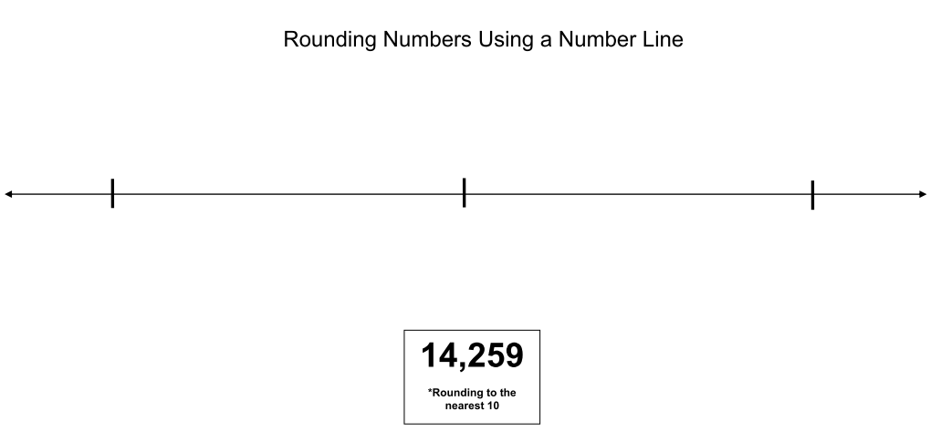

First ask yourself, “What am I rounding to?”______________________

Next ask yourself, “What information do I need to know to use the number line?”_________________________________________________________________

______________________________________________________________________

Finally, “What labels will I need to put on the number line? Why?”

______________________________________________________________________

______________________________________________________________________

Example 2

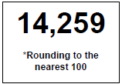

First ask yourself, “What am I rounding to?”______________________

Next ask yourself, “What information do I need to know to use the number line?”_________________________________________________________________

______________________________________________________________________

Finally, “What labels will I need to put on the number line? Why?”

______________________________________________________________________

______________________________________________________________________

