Winter Warmth DRIVE!

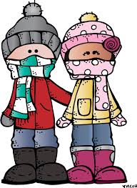

January 25th-February 17th
Please donate new hats, scarves, mittens, and gloves in all sizes to those in need.
Donated items will go to the Interfaith Works Clothing Center

Sponsored by Westover Student Council

