# 

**How I can support you and our school**

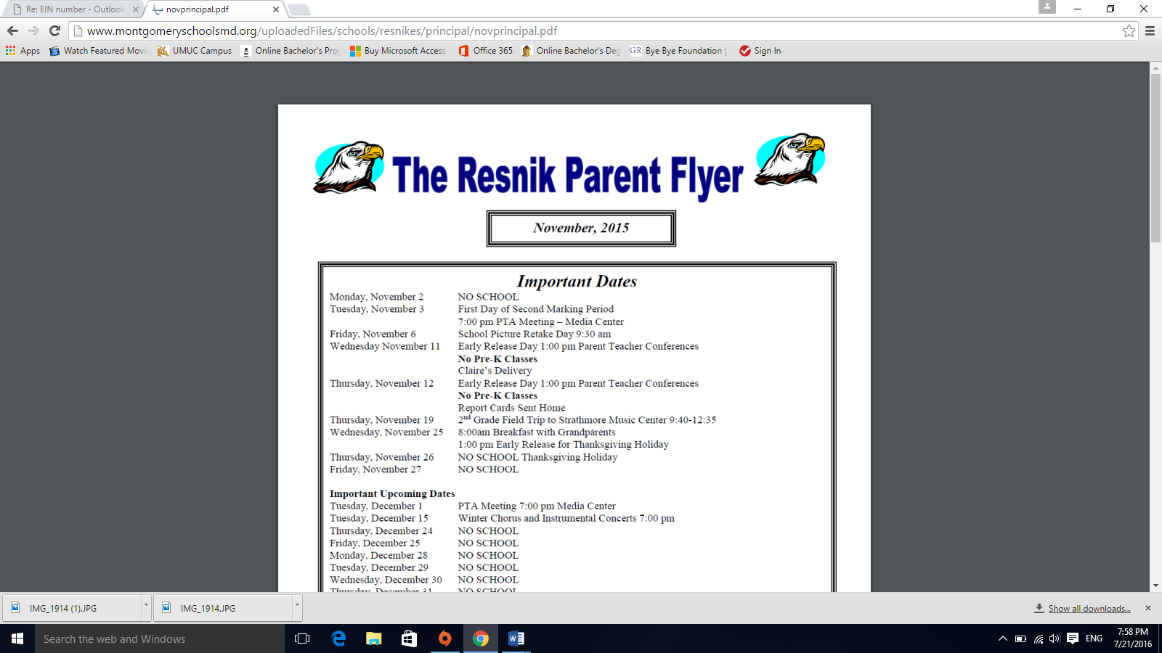

**Judith Resnik ES  
Mondays & Tuesdays**



**Washington Grove ES**

**Wednesdays & Fridays**

**Languages:**

**Spanish and English**

You can contact me through email:

[Magda_M_Sobalvarro@mcpsmd.org](mailto:Magda_M_Sobalvarro@mcpsmd.org)

or by phone:

240-550-4710

* Support families with referrals for community assistance (e.g., food, clothing, housing, counseling, county holiday basket program)
* Support parents and staff before, during and after the EMT and IEP process with attendance, forms, guidance and clarification
* Support school-home/parent communication with written and verbal foreign language needs in specific situations
* Provide educational support to parents by referring them to classes for personal development and fulfillment (English, computer, financial literacy, employment etc.)
* Support PTA with translation needs
* Serve as a contact for staff to support communication with parents regarding attendance, academic, social-emotional or health issues. etc.
* Provide referrals for families impacted by COVID-19
* Support parents with their MCPS parent vue accounts
* Support with the FARMS forms process during the year
* Provide parents with learning opportunities by working with community partners and Linkages to Learning to coordinate parent coffees/workshops, meetings, events
* Provide support to staff on training and orientation of volunteers

# Magda M. Sobalvarro-Ochoa

[Magda_M_Sobalvarro@mcpsmd.org](mailto:Magda_M_Sobalvarro@mcpsmd.org)

PARENT COMMUNITY COORDINATOR

**Montgomery County Public Schools**

**Division of Student, Family and School Services**

**Office of Student & Family Support & Engagement**