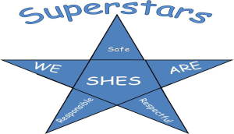**Summit Hall Expectations for Home**

MCj03587670000[1]

|  |  |
| --- | --- |
| **I am respectful.** | I listen to my parents.  I am truthful to my parents.  I play cooperatively.  I speak nicely to others. |
| MCj04079980000[1]**I am responsible.** | I put away my toys, bike and equipment.  I help with jobs at home.  I follow my parents’ directions.  I share my papers and take home folder with my parents  I am prepared for school:   * Share assignment notebook with parent/adult * Finish homework and share with parent/adult * Go to bed on time * Get up and get ready for school |
| MCj02911040000[1]**I am safe.** | I play safely with others.  I stay in designated areas.  I stay away from strangers.  I wear a bike helmet and equipment. |