BOX TOP$ for Education
- You need a smartphone with a camera to submit receipts in the BoxTops App.
- Go to your app store on your smartphone.
- Type BoxTops into the search. The app will look like this and is a free app.
- Download the App and Open.
- When you make a purchase at a participating retailer for a box tops item, you will see this symbol on the product packaging.
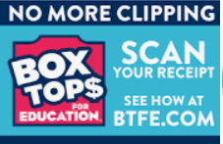
- Go to the app and select the school you want to earn BoxTops rewards for: Stedwick Elementary School. Save. You will only need to do this once because the app will keep the school saved, unless you change it.
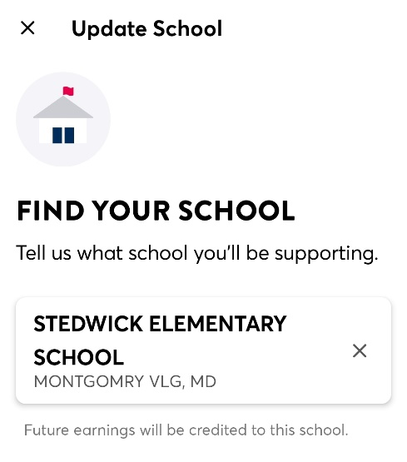
- Click the Scan button near the bottom of the screen. 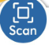
- Take a photo of your receipt using your phone. Add a section for receipts that are longer, by clicking + Section. Then Submit. The App will tell you how much you earned on your receipt. This will go toward Stedwick!
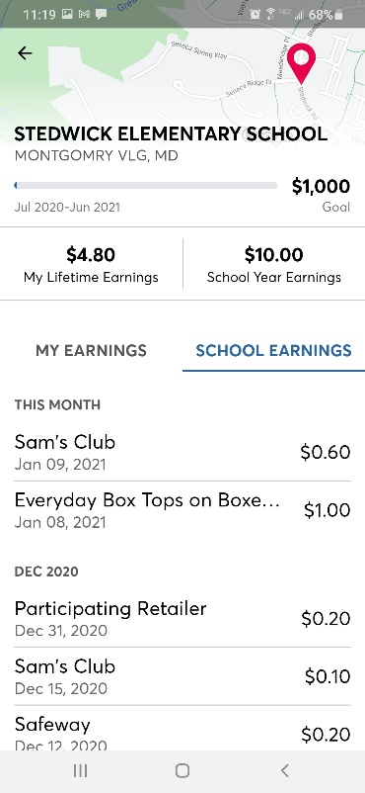
- You can also track the Stedwick goal and progress toward the goal.
- You can see what products are “BoxTops” eligible and what BoxTop items are currently earning bonuses.
- You can also follow BOXTOP$ on Instagram to keep up with updates and bonus offers. @BTFE

- Please feel free to share with friends and family. A little bit adds up over time. This is a very easy way to earn money for Stedwick!
- If you have any questions or ideas for promoting this, you can reach out at lauren.vanduuren@gmail.com.
- For a demo of how to use the app, see the video below: https://www.youtube.com/watch?v=v-bNcykyK5Y

