Dear Parents and Guardians,

MCPS is planning a wide range of summer programs for elementary, middle and high school students. Programs will focus on helping students engage in unfinished learning following this unprecedented school year, with a focus on mathematics, literacy, enrichment/specials, and preparing for the next grade level. Below you will find information about our in-person summer school program and the MCPS Virtual Summer School Program.
Summer School Registration Community Message- Elementary and Middle School Programs_SPANISH

MCPS Virtual Summer School
Virtual Summer School is being centrally organized by MCPS.
Registration using Parent-VUE
Scan the QR code or go to https://md-mcps.edupoint.com/PXP2_Login.aspx to register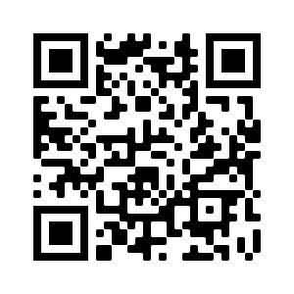
Available from Monday May 3, 2021 - Friday, June 4, 2021
Tuesday, July 6, 2021 through
Friday, July 30, 2021
for a total of 19 days.
Monday - Friday
8:30am-12:30pm
4 hours per day
Math
English Language Arts
Special (elementary school programs)
Electives (middle school programs)
Enrollment is Limited
Visit the MCPS Summer Programs webpage.
HERE

