**Principal’s Message**

Principal’s Message 1

Dates to Remember 1

PTA News 4

Patriot Student of Month 6

Important Info 7

In ThIS issue:

Dear GES Families,

Fall is always a **festive time of year**! We hope everyone enjoyed the Halloween festivitieshere at school. And thanks to Mrs. Atanda for planning some great alternative activities for our students who do not participate in Halloween. Huge thanks to the PTA for hosting a great Harvest Dance and Book Fair as well.

With the holidays coming up we want to let parents know once again that we have several options to **help families who may be in need:**

* Women Who Care Ministries, a local non-profit agency, offers a “Helping Kids Eat Weekend Food Program” which provides healthy snacks for children for the weekend. Each week, on Fridays or before planned school breaks, children are confidentially provided with a bag containing kid-friendly, nonperishable, and vitamin-fortified and easily consumed, food items. The foods cover the dairy, protein, grain, and fruit food groups.
* Agape AME Church will provide 20 Thanksgiving food baskets to GES families in need. This will be the church’s second year providing this support.
* The Holiday Giving Project, a program coordinated by an organization called A Wider Circle, provides: Winter holiday help –A few toys for children and food to supplement a holiday meal. Please note, The Holiday Giving Project does NOT supply an entire holiday meal, or an *abundance* of toys – the program is designed to be supplementary.

Also note, a limited number of backpacks and supplies are available to those families who request assistance. If you have any questions please contact Mrs. Atanda (School Counselor) at 301-353-8050 or [Jennifer_T_Atanda@mcpsmd.org](mailto:Jennifer_T_Atanda@mcpsmd.org).

**Germantown Elementary** 19110 Liberty Mill Road Germantown, MD 20874 Phone: 301-353-8050

**GES Website** Montgomeryschoolsmd.org/ schools/germantownes/

Contact: Jaime Howenstein

[jaime_b_howenstein@mcpsmd.org](mailto:jaime_b_howenstein@mcpsmd.org)

Listserv: Join and stay up-to-date! To sign up, send an email to GES-PTA [subscribe@yahoogroups.com](mailto:subscribe@yahoogroups.com) or click the Join button on our website [www.ges-pta.org](http://www.ges-pta.org)

**Patriot Newsletter Editor:**

Kris daCosta-Warshauer [KdacW35@gmail.com](mailto:KdacW35@gmail.com)

MC900001544[1]

*Continued on pg 2…*

**Dates to Remember**

*Principal’s Message continued …*

**Nov 7** Early Dismissal @ 1:15 pm

**Nov 9**  PBIS Breakfast, 8:45 am for selected classes that earned it

Creole for Kids performance for grades 1-2 classes, 10 am

**Nov 12**  Early Dismissal @ 1:15 pm. Parent-teacher conferences.

**Nov 13** Early Dismissal @ 1:15 pm. Parent-teacher conferences.

NO AFTER SCHOOL CLUBS

**Nov 20** After School Clubs meet

Guitar class meets in art room, 4 – 5 pm

**Nov 23** Early Dismissal @ 1:15 pm

**Nov 24**  Thanksgiving Day – schools closed

**Nov 25** Holiday – schools closed

**Nov 26** GES restaurant fundraiser @ Panda Express, 5-8 pm

From time to time, we are going to highlight information contained within the **GES Policies and Procedures** that was distributed at the beginning of the school year and is posted on our school’s website. Information on absences is the one of the first items within the document. As a review, it reads as follows:

***ABSENCES:*** *Please call our school at (301) 353-8050 before 9:15 A.M., if your child will be absent. The answering machine will take your message between 4:45 P.M. and 7:45 A.M. In addition, a written explanation of each absence is required from the parent or guardian when the student returns to school.*

*Please note, a monthly list of students’ tardiness or absences is generated by the school system and sent to the principal. Students who are late and/or absent more than 3 times each month (excused or unexcused) will receive a letter from the principal. Students who are absent 20% or more days of school are considered habitually absent and may be referred to the Truancy Review Board.*

As we **prepare for the Thanksgiving holiday** please know that we am thankful for the children you send to us each day. They bring life and laughter to this building and to my heart! Have a wonderful holiday, enjoy your precious family time, and be safe in your travels! I am signing off for now. Please call (301- 353-8050) or email us ([Amy_D_Bryan@mcpsmd.org](mailto:Amy_D_Bryan@mcpsmd.org) or Carolynn_Walsleben@mcpsmd.org) if you have a question, comment or concern.

Take care,

Amy D. Bryan & Carolynn Walsleben

Principal & Principal Intern

Follow Mrs. Bryan on [](https://www.google.com/imgres?imgurl=http://cnet2.cbsistatic.com/hub/i/2012/06/06/b8ba2ec1-fdb6-11e2-8c7c-d4ae52e62bcc/2f74add282f3095513ce5eee2d150cac/FDNews_newtwitterlogogrey.jpg&imgrefurl=http://www.cnet.com/news/twitter-introduces-ticker-symbol-cashtags-for-finance-searches/&docid=VL65mvfKlXuOlM&tbnid=-ULM1Az90yvrQM:&w=300&h=214&ei=vlAkVPOTFoOiyATKuYD4CA&ved=0CAIQxiAwAA&iact=c) *@TeamGermantown1*



GES Restaurant Fundraiser!

Take a break from the holiday leftovers by treating yourself and your family to Panda Express in Germantown Town Center. The restaurant will donate a % of sales to GES field trips for grade 4-5 students.

Monday, November 26th

5 to 8 pm



**Earn money for GES!**

**Collect and bring Box Top labels**

**to your child’s teacher!**

**Additional School News**

**PBIS PATRIOT Breakfast – Congratulations** to the following GES classes that earned a PATRIOT BREAKFAST because they were RESPECTFUL, RESPONSIBLE and SAFE during the first marking period!

Mrs. Brown*

Mrs. Edmundson

Ms. Horvath

Mrs. Kissal

Mrs. Lea*

Ms. Marino*

Mrs. Minehan

Mrs. Rockovich

Mrs. Savino

Mrs. Wysong

Note the classes indicated with * are homeroom classes. Each student from the classes named above and one adult of his/her choice (parent, adult relative, staff member, etc.) are invited to celebrate their classes’ success at our 1st GES Patriot Breakfast on Friday, November 9th. We respectfully ask that invited guests not bring younger siblings to this special event. This breakfast is being sponsored by our partners at the Educational Systems Federal Credit Union. If you have any questions, please contact your child’s teacher.

**Partnership with Black Rock Center (from Mrs. Bryan and Mrs. Walsleben) –** We are excited to share with you news about a partnership we, as a school, are developing with **BlackRock Cultural Arts Center** located in Germantown Center. This partnership will provide opportunities for all our students ranging from performances here at Germantown Elementary School to accessing BlackRock’s Ballet Outreach Program*.  We are also looking forward to Black Rock’s first visit to GES on November 9th, and having the group **Creole for Kids** perform an acoustic version of the play for the first and second graders. We truly believe that developing this partnership with Black Rock will provide opportunities for our students to experience multiple areas of the arts, both during and outside of the school day.

*\*The Ballet Outreach Program will provide the opportunity for our students to access ballet lessons at a reduced price; please be on the lookout for information about the upcoming winter session.*

**Middle School Magnet Testing –** Testing for all 5th graders (unless testing was declined) for the Middle School Magnet programs will take place on Wednesday, Nov. 14th at 9:30am at GES.  Be sure your child is well rested, eats a healthy breakfast and is at school on time.  If you have any questions, please contact, Amy Taylor at 301-353-8050.

Students’ Health Matters at GES!

**Chap Stick –** The health room staff at GES would like to inform our parents that lip balms or chap sticks are permitted at school (without forms). We encourage students to have them in the back pack for use before going outside for recess. Please remind your student that sharing lip balms or chap sticks is not permitted. Thank you!

**Montgomery County Flu Shot Clinic at Northwest HS - 11/13:** The Montgomery County Department of Health and Human Services is sponsoring a free flu shot clinic for children between the ages of 3 and 18 on Tuesday, November 13, from 1:30 pm to 4:00 pm in the Northwest cafeteria. To make an appointment, please visit <https://www.montgomerycountymd.gov/resident/flu.html>.

**Free Dental Screenings @ GES:** On Wednesday, December 12th any GES student or sibling aged 1-12 (with written parent permission*) will be able to receive a free dental screening in the Colgate Mobile Dental Clinic van at Germantown Elementary School. The screening, performed by a dental professional, will take approximately 2 minutes to complete. The screening findings with referrals for follow-up treatment will be given to the student for parent/guardian review at a later date. Once the screening is completed, each child will receive an oral care kit containing toothpaste, toothbrush and brushing instructions.

*\*Parent permission forms will be available at parent-teacher conferences.*

**PTA News**

Dear Patriot Parents, Teachers and Staff:

Welcome to November! This month invokes a sense of thankfulness, and I hope we all remember to be thankful each and every day. Among the things to be thankful for is that we have a great community of people who want the very best for GES students!

The PTA’s Harvest Dance on October 26th was truly for all! Many thanks to **Renee Walker** and her team of volunteers for putting together this fantastic event. Many thanks also go to **Katy Stermer** and her team volunteers who attended a Manna Food volunteer event on October 23. Way to go!

Due to the school’s closure on November 6, our November PTA meeting will be held **tonight** (Wednesday, November 7, 2018, 7:00 p.m.) at the Panera Bread located at 20680 Seneca Meadows Parkway in Germantown, MD (near Wegman’s). Following the November meeting, our next member-wide PTA meeting is scheduled for Wednesday, January 3, 2018, 7:00 p.m., in the GES media center.

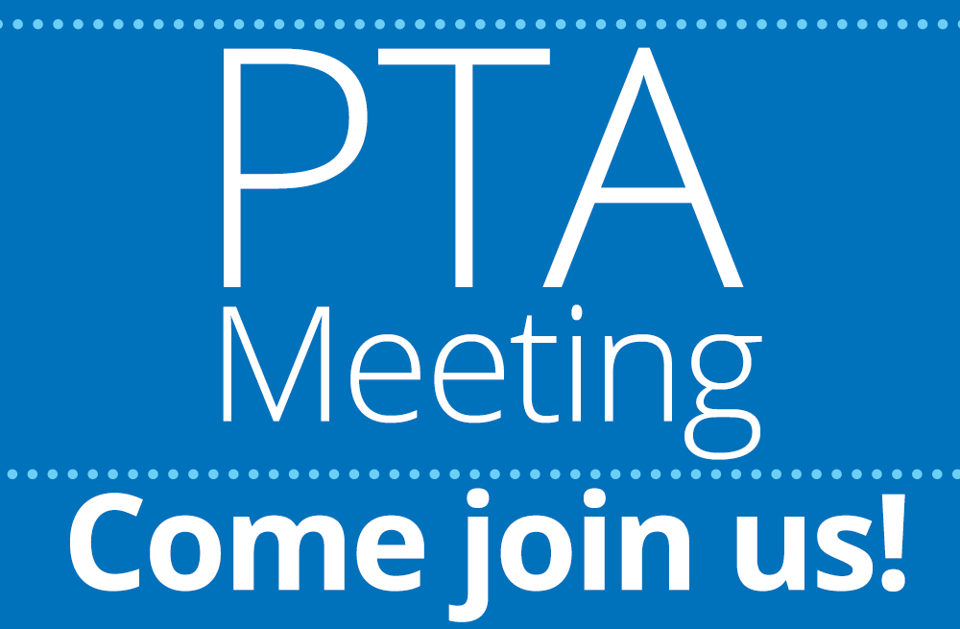

Convenient fundraising through your shopping needs!

Over the holidays, please remember that the GES PTA has a special program through AmazonSmile! Amazon donates 0.5% of the price of your eligible AmazonSmile purchases to the GES PTA. AmazonSmile is the same Amazon you know - same products, same prices, same service. Support the GES PTA by starting your holiday shopping at[*smile.amazon.com*](https://smile.amazon.com/gp/f.html?C=3MD3N1G6RP25I&K=1S3N4ZR9CDZ4C&M=urn:rtn:msg:201808081634426a2f74410f594bc5aa8c8117d490p0na&R=JKF0GD8AP64B&T=C&U=http%3A%2F%2Fsmile.amazon.com%2Fch%2F23-7031179&H=AQY9CVGPAEAMEMGBEGJ9AHAUQQYA)

GES also has a great awards program through Giant! The [A+ School Rewards Program](https://giantfood.com/member-benefits/) currently runs now through March 16, 2019. Giant has donated over $36 million to local schools through the A+ School Rewards Program. Customers register their Giant Card and can support up to two (2) schools. Sign in to your account (or register for an account) to link your Giant Card to your school. Selected school(s) earn money from your qualified purchases during the program period. If you need assistance, call Giant Customer Care at 877-366-2668 select option 1.



Lastly, I need help organizing the PTA members’ 2018 Holiday Party to be held in December *(date TBA).* I am **looking for 2-3 volunteers** that are not already serving on a committee or otherwise volunteering in a PTA position. If you are interested in planning this holiday party, you may e-mail me at [LLydiarose@aol.com](mailto:LLydiarose@aol.com).

Happy November and please feel free to e-mail me if you have any questions or concerns!

Sincerely yours,

Lydia Rose

GES President

**Thank you and tidbits from PTA committee chairs:**



From book fair coordinator **Lourdes Pesseh**:

A big thanks to students, staff and families for visiting our Enchanted Forest Book Fair! The PTA hopes that everyone will enjoy reading their new books and letting their imaginations grow.

Thank you to all the volunteers who helped make our Fall 2018 book fair a success! Special thanks to **Megan Lowery, Claudia Osegueda, Danielle Story, Jill Hurley, Ms. Howenstein, Ms. Cole, Ms. Taylor** and **SSL students.**

Our BOGO Spring 2019 book fair will be June 3rd -7th …it will be **“Dinomite”**…look for details next Spring!

From Hospitality chair **Melissa Matchett**:

The Donuts for Dads event on October 8th was a success!  Many students and their dads/father figures showed up and enjoyed delicious donuts, coffee and juice.  Special thanks to the following volunteers who helped to make this a great event:  **Hiranthie Webster, Becky Miller, Jill Hurley, Trisha Flager, Heidi Casta,** and**Ana L. Rivera de Garcia.**





Thank you to those who have joined the PTA so far this year!  We are up to **106** members.  We came a little short of our goal. We continue to encourage ALL families to support their children and the school by joining the GES PTA.  Congratulations to our winners drawn from our PTA Membership drive - each of the following won an Amazon gift card: Jessica Gonzalez, Stacey Anderson, Rabia Aydin, Kevin Miller, and Audrey Boettcher. Questions about joining the PTA, contact PTA Membership Chair by email [Tisha Chrobak](mailto:chrobaktisha@gmail.com).

**PTA Read-A-Thon reminder:** The Read-a-Thon is coming to a close this Friday! This is the main fundraiser for the PTA for the school year so we need everyone’s support. Students can log into their individual accounts to document 15 minutes of reading at school and another 15 minutes at home. We’re looking forward to finishing strong!

Patriot Student of the Month

(October 2018)

|  |  |  |  |
| --- | --- | --- | --- |
| **Kindergarten** |  | **Fourth Grade** |  |
| *Mrs. Malek* | Ange | *Mrs. Kahn* | Tyasia |
| *Mrs. Savino* | Dani | *Mr. Kaigler* | Noah |
| *Mrs. Wysong* | Christian |  |  |
|  |  |  |  |
| **First Grade** |  | **Fifth Grade** |  |
| *Ms. Horvath* | Chrissa | *Mrs. Boucher* | Ishly |
| *Mrs. Minehan* | Aisha | *Ms. Marino* | Emma |
| *Mrs. Rockovich* | Sanad |  |  |
|  |  | **SCB** |  |
| **Second Grade** |  | *Ms. Farrell* | Gabriel |
| *Mrs. Booth* | Charles | *Ms. Gray* | Kailani |
| *Mrs. Edmundson* | Keith |  |  |
| *Mrs. Kissal* | Noah | PEP 5 Hour (*Mrs. Ho*) |  |
|  |  | PEP Classic (*Mrs. McKenzie*) |  |
| **Third Grade** |  | PEP Pilot (*Mrs. McKenzie*) |  |
| *Mrs. Brown* | Aissatou |  |  |
| *Mrs. Lea* | Raina | Peacemaker of the Month | Zoe |
|  |  | Patrol of the Month | Anita |



**2019–2020 School Year Calendar (English and Spanish)**

MCPS is developing the school calendar for the 2019–2020 school year. The Board of Education held a discussion at its business meeting on October 9, 2018, about the process, options, and challenges for developing the calendar and is considering two potential calendar scenarios.

As the district develops a calendar, it must start with several requirements from the state:

* September 4–June 15: the permissible time frame for instruction
* 180: the minimum number of instructional days required
* 15: the number of state-mandated days that schools must be closed
* 3: the number of snow make-up days required at the end of the year (before June 14)

For a more detailed explanation of the calendar process, visit the [2019–2020 calendar webpage](https://www.montgomeryschoolsmd.org/calendar/proposed-calendar-2019-20.aspx#comments). The scenarios are posted on the MCPS website for public information and review. If you would like to offer comment on the calendar, please do so using the drop box provided on the calendar information [webpage](https://www.montgomeryschoolsmd.org/calendar/proposed-calendar-2019-20.aspx#comments).

The Board will hold a final discussion and adopt a final calendar later this fall. You can stay engaged and informed in this process by visiting the [Calendar webpage](https://www.montgomeryschoolsmd.org/calendar/proposed-calendar-2019-20.aspx#comments).

**Calendario Escolar 2019–2020**

MCPS está diseñando el calendario escolar para el ciclo escolar 2019–2020. Durante su reunión de negocios del 9 de octubre, 2018, el Consejo de Educación habló acerca del proceso, las opciones y las dificultades de desarrollar el calendario y está considerando dos opciones posibles para el calendario.

A medida que el distrito escolar desarrolla un calendario, debe comenzar con varios requisitos del estado:

* 4 de septiembre–15 de junio: el lapso de tiempo de enseñanza permitido
* 180: el número mínimo de días lectivos exigidos
* 15: el número de días que el estado ordenó que las escuelas deben estar cerradas
* 3: el número de días de recuperación de tiempo de enseñanza por días de nieve que se necesitan al final del ciclo escolar (antes del 14 de junio)

Para una explicación más detallada del proceso del calendario, visite le página web del [calendario escolar 2019–2020](https://www.montgomeryschoolsmd.org/calendar/proposed-calendar-2019-20.aspx#comments). Las opciones están publicadas en el sitio web de MCPS para información y revisión. Si usted desea aportar un comentario sobre el calendario, por favor hágalo usando el buzón que se provee en la [página web del calendario escolar](https://www.montgomeryschoolsmd.org/calendar/proposed-calendar-2019-20.aspx#comments).

El Consejo tendrá una última conversación sobre el tema y adoptará un calendario definitivo más adelante en el otoño. Usted puede mantenerse involucrado/a e informado/a sobre este proceso visitando la [página web del calendario escolar](https://www.montgomeryschoolsmd.org/calendar/proposed-calendar-2019-20.aspx#comments).