Garrett Park Elementary School

Media Center News

What your student will do in the Media Center

By Barbara Bickford, Media Specialist and Sandi Marsden, Media Assistant
Welcome to the Media Center for another wonderful year of learning!
Ms. Bickford and Mrs. Marsden wanted to share with you what your child will be learning and doing in the media center this year.
Your student will learn:
- Fiction & Nonfiction and where to find Media Center materials
- The Maryland Black Eyed Susan Award and vote for the winner of this annual prize
- How to effectively use online databases and resources for work completion
- Media literacy, how to be a responsible digital citizen
- And so much more!

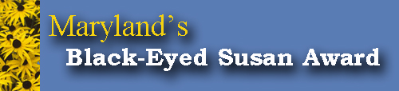

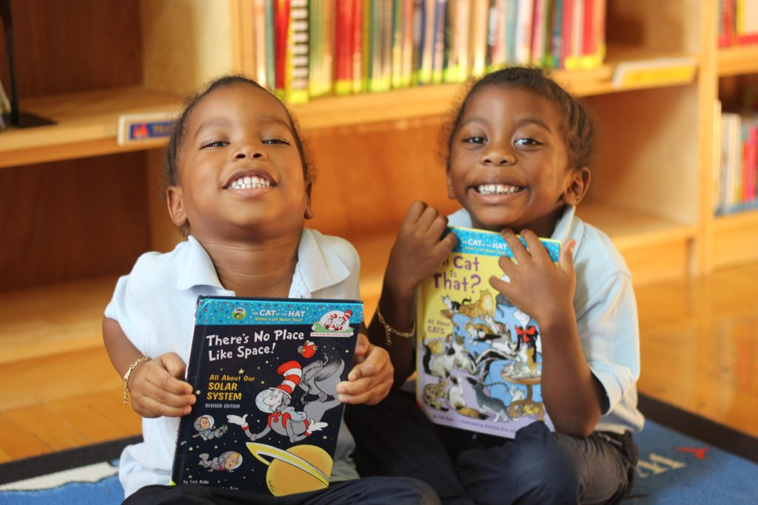

Your Child Will Check Out Books
Kindergarten: one book
First and Second Grades: Two books or magazines
Third, Fourth and Fifth Grades: Three books or magazines (Students may have only one audiobook at a time).
If students need extra books for class work or projects, they can check out more.
They may check out books for two weeks at a time. If they would like to return their books earlier they can check out more at that time. Overdue book notices will be sent out periodically throughout the year.
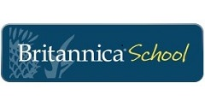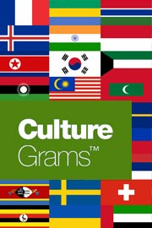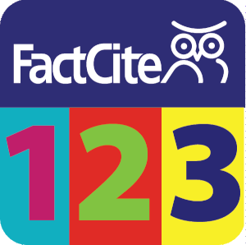

Read More on Our Website

