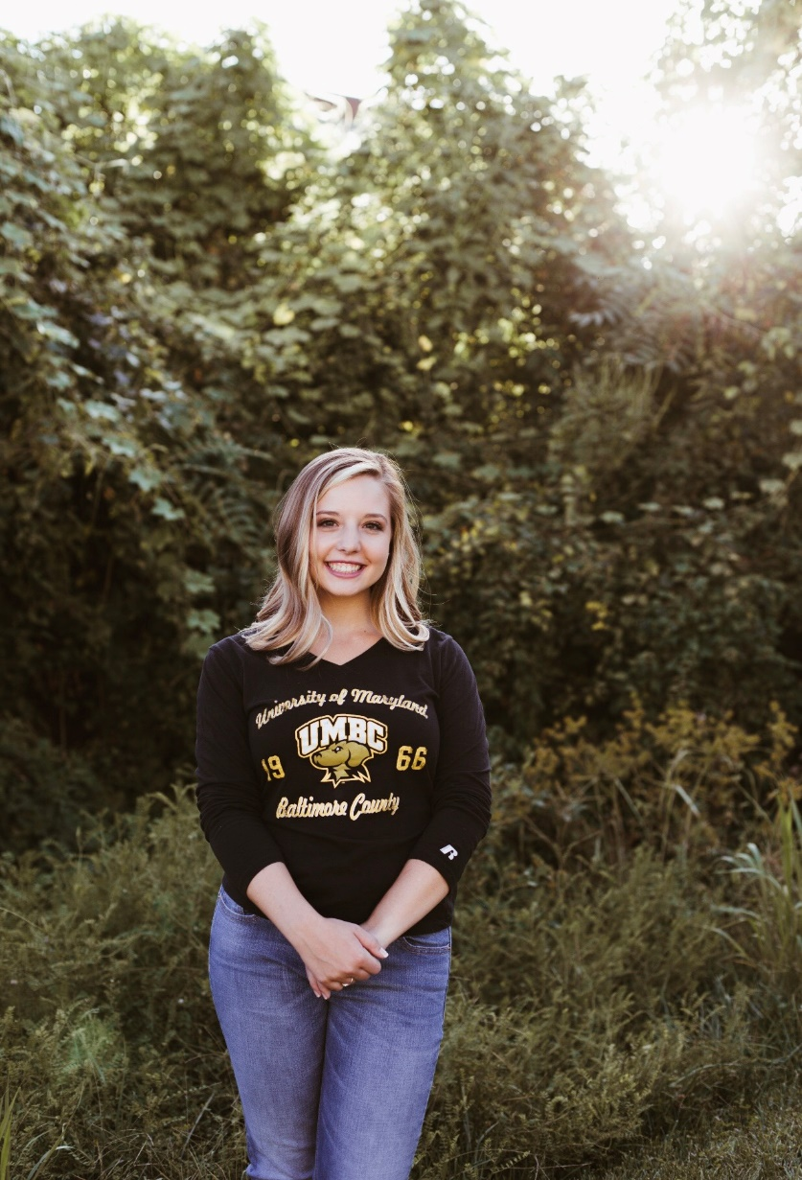

Hi, I’m Nicole Scarola and I am the counseling intern working alongside Mrs. Jenny Fleming this school year. I am currently studying at Loyola University of Maryland to receive my Masters of Education in School Counseling. Before attending Loyola, I graduated from UMBC with a Bachelors in Psychology. I am a lifelong resident of Damascus, MD and am a proud MCPS alumni. Some of my favorite things to do are reading, spending time with my family and friends, soaking up the sun, and stamping my passport!

My passion is to encourage students to achieve their goals from a positive mindset. I’ve dedicated the past ten years of my life serving children in the community through teaching, coaching, and educating. I look forward to sharing these experiences with the Burning Tree Community.  I am always available for listening, talking, and creating a safe space for students!