Rainforest Room
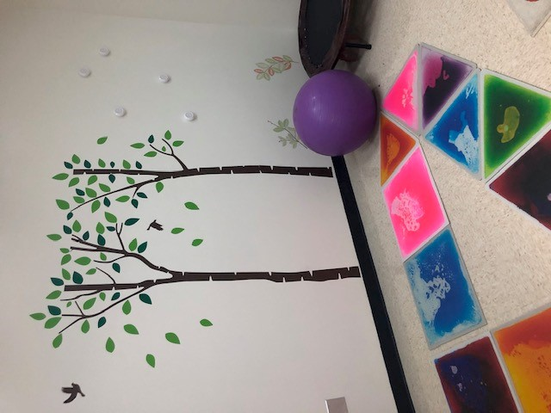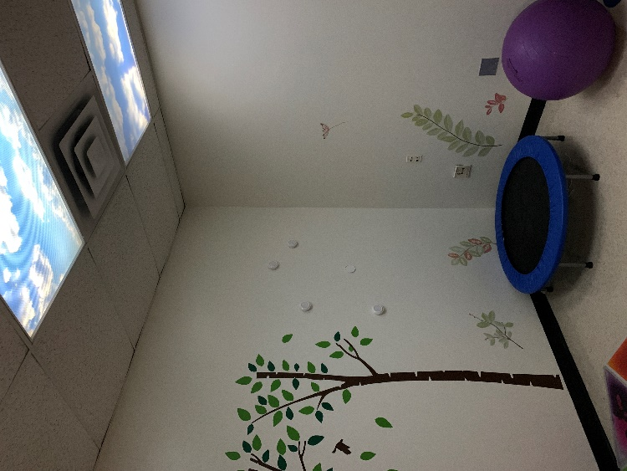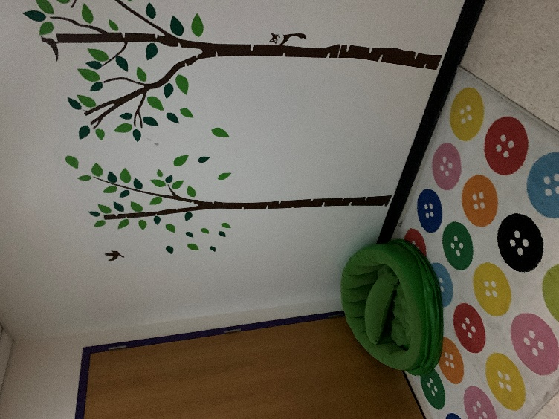
Students have the opportunity to visit the rainforest room given teacher permission. This mindfulness space has been intentionally setup to provide a calming, quiet space with tools to promote relaxation. Students are able to use a trampoline, rocker board or yoga cube to facilitate mindful movements and exhaust excess wiggles or energy. Students also have the option to use a relaxing space within this room where they have access to a cozy chair, carpet, and relaxing lights. Children or adults supervising their visit to the rainforest room will log them in each visit.

