Accessing the Google Calendar
- From your iPhone, open Safari and navigate to: sites.google.com/a/mcpsmd.net/aes-calendar
- When the calendar appears, you will see the “+ Google Calendar” button on the bottom, right-hand side of the calendar. Click this button.
- If you already have a Google account and it is linked with your iPhone you will be prompted to “Add Calendar.” Select this option.
- If you do not have a Google account, you will be prompted to create one. In order to access the calendar and sync it with your device, you must have a Google account.
- After you create the account, select “Back to Calendar.” You should now be able to see the Ashburton Elementary School Google Calendar. Any time you log into Google Calendar from a desktop or mobile device, you will be able to see the Ashburton calendar.

Syncing your iPhone calendar with the Ashburton Elementary School Google Calendar
- Navigate to the site: https://www.google.com/calendar/iphoneselect
- Once there, select the calendars that you would like to be able to sync with your iPhone calendar. Click “save.”

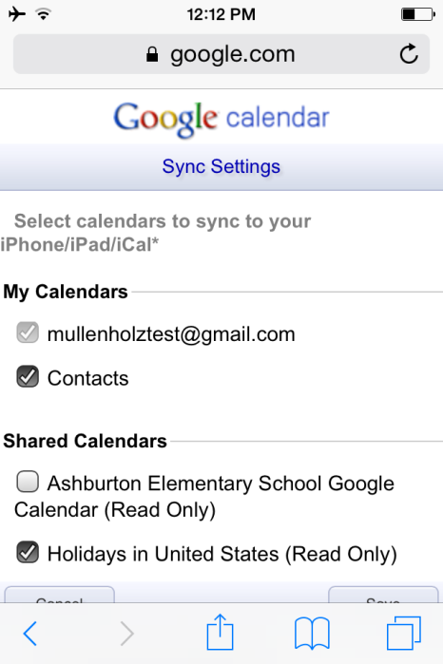
- If your iPhone is already synced with your Google calendar, all of the Ashburton school events will now appear on your calendar.
  - Open your calendar, select “Calendars,” and make sure the Ashburton Elementary School Google Calendar has a check next to it.
- If you have never synced another calendar with your iPhone calendar, use the following steps:
  - Open settings
  - Select “Mail, Contacts, Calendars”
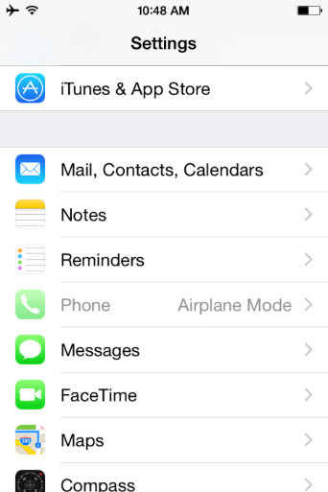
  - Select “Add Account”
  - Select “Google”
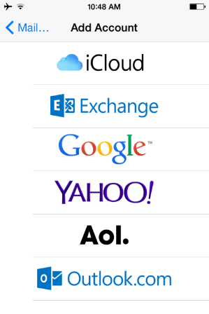
  - Log into your Google account
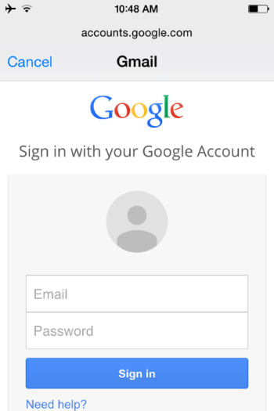
  - Select “Accept”
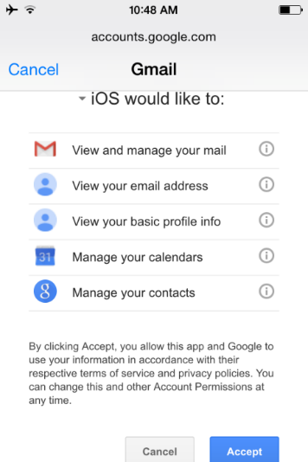
  - Mail, Contacts, Calendars, and Notes are all turned on for synchronization. Turn off those that you do not wish for your phone to sync with. In order to have the Ashburton calendar synced to your device, you must have “Calendars” turned on.
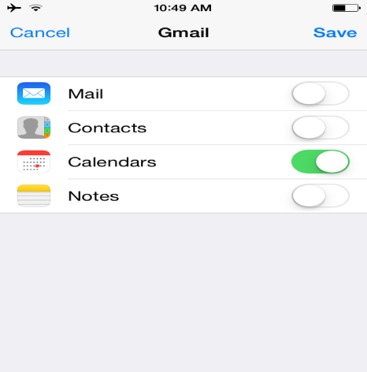
  - Select “Save”
  - Navigate back to your iPhone Calendar
  - Select “Calendars” and ensure that the Ashburton calendar is selected.
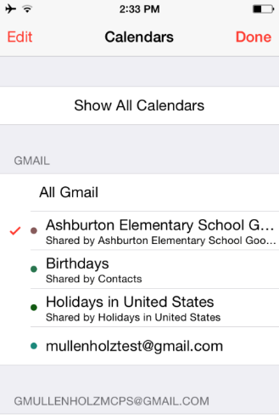
- Your calendar is now synced with the Ashburton calendar and all school events and information will automatically be synced with your mobile device. In order to ensure that you also get any changes, additions, or updates, ensure that your phone is set to “Fetch New Data.” To do this, open Settings>Mail, Contacts, Calendars and select “Fetch New Data.” At the bottom of the menu, select 15 minutes, 30 minutes, Hourly or Manually. Select whichever option works for you and your data plan!
