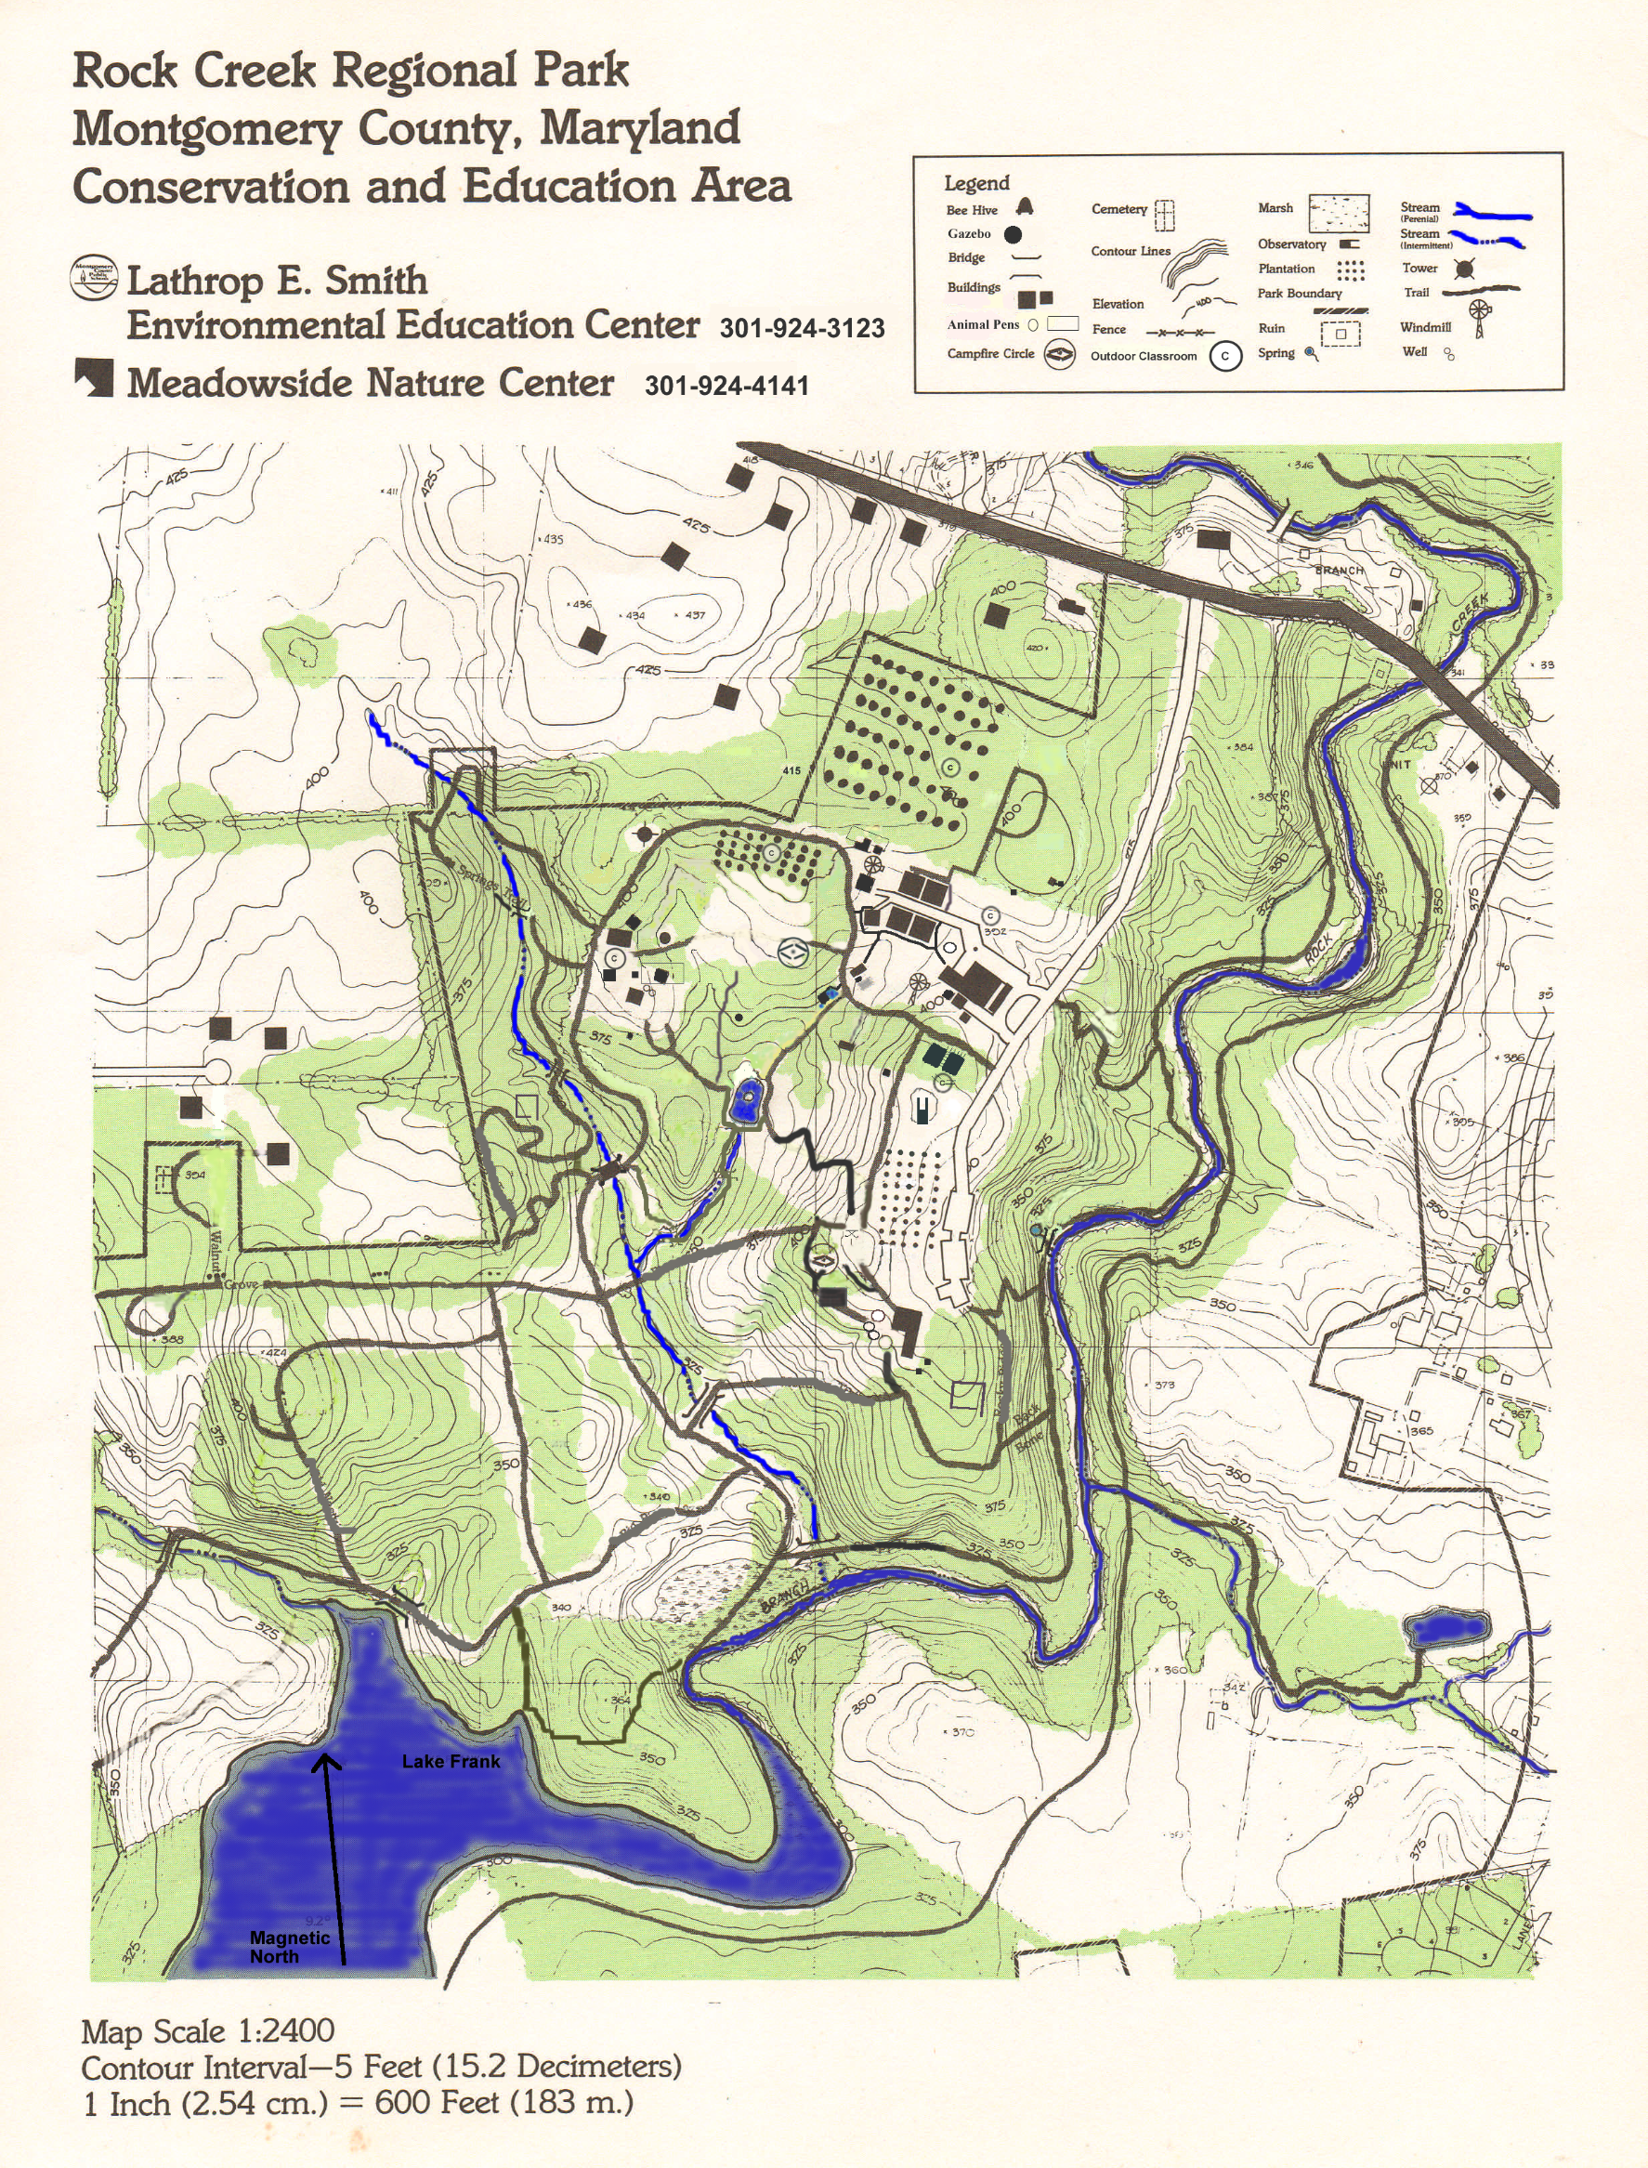
PATTERNS OF SETTLEMENT
Updated June 2016
Trail Marker
8
9
7
6
1
2
5
4
3
11
10
Muncaster Mill Trail
MEADOWSIDE LANE
Pioneer
Trail
MUNCASTER MILL ROAD
Springs Trail
Muncaster Mill
Trail
PREDATOR PREY FIELD #1
Muncaster Mill
Trail
Lakeside Trail
Rocky Ridge
Back
Bone
Big Pines
CONFIDENCE COURSE
PREDATOR PREY
FIELD #2
Trail
Lakeside
Trail
Lakeside
Old Nasty

Patterns of Settlement, Smith Center
The geocaches are placed near various landmarks, always close to a trail. When your GPS says you are within 40 feet use the clues to help you find the hidden geocache. Open the cache to discover what the challenge is. Fill in the data sheet with your best answers and return to the starting point when you are finished or out of time.
Clues:
1. Near a pond 2. Near the cabins
3. Near a grove of trees 4. Near the Springs Trail
5. Near the top of a hill 6. Near the nature center
7. Along the stream 9. Near the ruins
10.the bend in the stream 11. On the east side of the stream

USING THE GPS –To find a waypoint
- To turn the GPS unit on, press and hold the POWER button.
- Use the Rocker button to highlight Waypoint Manager and press Enter.
- Use the ROCKER buttons to highlight the letter we need and press ENTER. Use the ROCKER buttons to highlight DONE and press ENTER.
- Use the ROCKER button to scroll to the Waypoint you are going to first and press ENTER.
- The “Waypoint” screen appears, select Go To by pressing ENTER.
- Press the BACK button to get to the compass page. Use the ROCKER button to scroll to the Compass and press Enter. The arrow on the compass points in the direction you need to go.
- Follow the arrow to your destination. You may need to adjust your line of travel to go around obstacles and stay on the trail.
- The GPS has an accuracy of about 30 feet, so when you are close look all around to find the point you are looking for.
- When you are ready to select the next waypoint, press the PAGE button until you see the Menu page, select Find and follow these instructions again.
- The Dist to Next (Distance to Next) is very helpful. Remember When the number goes down, you are closer to your destination.

GPS Tips
- If you ever get to a page you don’t want to be on, press the Back button.
- The GPS will not take you exactly to your point – the accuracy is within 30 feet.
3. Enter/Rocker

- The Compass page tells you the time.

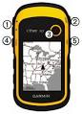
SAFETY REMINDERS
- Do not cross large streams.
1.In/Out Zoom
2. Back
- No Running.
- Stay on the trails.
5. Power/Light
- Stay with your group.
4.Menu
- Respect the park.
- Return on time.

