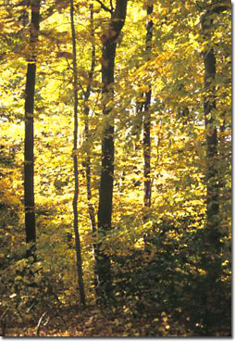
Healthy Forests Help the Bay
When Europeans first arrived to the Chesapeake Bay region in the 17th century, they found vast, diverse forests covering 95 percent of the Bay's 64,000-square-mile watershed. Today, forests cover about 58 percent of the watershed, or 24 million acres. While forest conditions have changed over the past 400 years, forests still remain critical to the health of the Bay, its residents and its wildlife.
Benefits of Forests
Chesapeake Bay forests perform crucial functions that benefit all plants and animals — including humans — such as filtering pollution, creating habitat and providing shade.
Forests Protect Clean Water
- Forests act as giant sponges that absorb and slowly release pollution.
- Mature trees have deep root systems that hold soil in place, helping to stabilize stream banks and reduce erosion.
Forests Provide Habitat for Wildlife
- Healthy forests provide food, shelter, nesting sites and safe migration paths for critters in the water and on the land.
- Streamside forests shade the water, keeping the water temperature cool in the summer.
- Decaying leaves and wood on the forest floor are also essential links in the food web.
Forests Clean the Air
- Forests absorb and trap pollution released into the atmosphere by cars, factories, agriculture and construction.
- Trees also produce the oxygen that we breathe.

Riparian Buffers
Riparian buffers are the area of trees and other vegetation along a stream or river that is managed to reduce pollution entering the waterway, and to provide food, habitat, and thermal protection for fish and wildlife. They are usually 20-200 feet, although a minimum of 100 feet is recommended to fully protect the stream. These areas have the same benefits as the forest listed above, but are even more important because they are so close to the stream.

What Does a Healthy Forest Look Like?
A healthy forest is a complex, interdependent community of plants, animals and soil. Each layer of the forest provides diverse habitats and helps to protect clean water. A healthy forest should have the following layers:
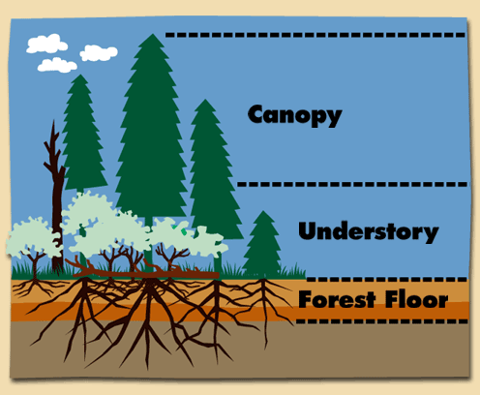
- The canopy is the forest's top layer. It shades and protects animals and plants below, while also intercepting and slowing rainfall.
- Beneath the canopy is the understory, a second layer made up of smaller trees and shrubs.
- The next layer, the forest floor, is populated by vines, grasses, mosses, worms, insects, fungi, bacteria and other small plants and animals. They continually decompose leaves, wood and other organic material that falls to the forest floor so that it may be reused by larger plants. This layer is also a storehouse of nutrients.
Soil
- The litter on the forest floor protects the soil, the bottom layer of the forest. Healthy forests often contain more living biomass in the soil below ground than on the surface.
Adapted from http://www.chesapeakebay.net/forests.aspx and the NRCS Planning & Design Manual

