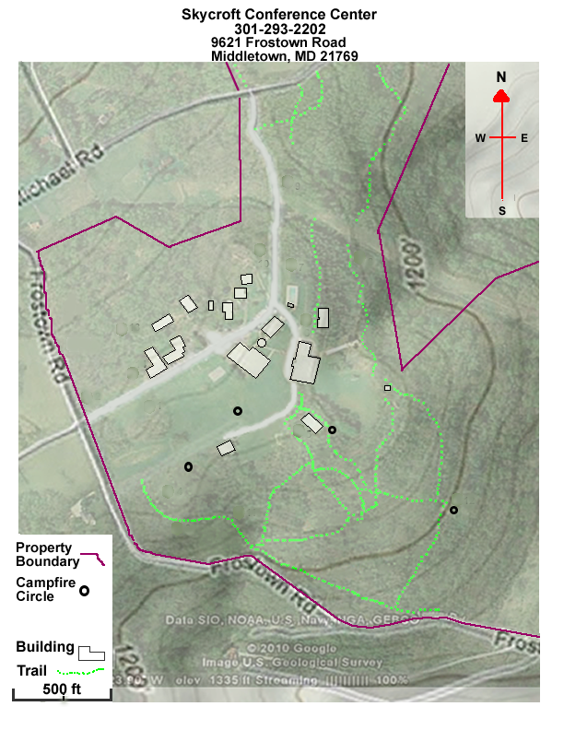
9
12
11
10
4
8
6
5
3
2
7
1

Treasure Earth – Skycroft Course
The geocaches are placed near various landmarks. When your GPS says you are within 40 feet use the clues to help you find the hidden geocache. Open the cache to discover what the challenge is. Fill in the data sheet with your best answers and return to the starting point when you are finished or out of time.
Clues:
1. In field outside of classroom 2. Near a crooked but cool tree
3. Behind a bench, between the hotels 4. Near a lone tree, surrounded by rocks
5. Near a covered water fountain 6. Between a picnic pavilion and a campfire
7. Bottom of a hill near a drainage pond 8. Near campfire with a great view
9. Large lone tree, near a small pavillion 10. Near post 13, inside woods
11. Near post #14, then 20 paces west 12. Southern edge of large drainage ditch

USING THE GPS – Garmin Summit HC To find a waypoint
- To turn the GPS unit on, press and hold the POWER button.
- When you are no longer on the “Acquiring Satellites” page, you are locked onto the satellite signals. (You must acquire satellites before you can use the GPS to navigate.)
- Press the PAGE button until you get to the Menu Page.
- Use the ROCKER buttons to highlight Find and press ENTER.
- Use the ROCKER buttons to highlight Waypoints and press ENTER.
- Use the ROCKER buttons to highlight the letter we need and press ENTER. Use the ROCKER buttons to highlight OK and press ENTER.
- Use the ROCKER button to scroll to the Waypoint you are going to first and press ENTER.
- The “Waypoint” screen appears, select Go To by pressing ENTER.
- Press the PAGE button to get to the compass page. The arrow points in the direction you need to go.
- Follow the arrow to your destination. You may need to adjust your line of travel to go around obstacles and stay on the trail.
- The GPS has an accuracy of about 30 feet, so when you are close look all around to find the point you are looking for.
- When you are ready to select the next waypoint, press the PAGE button until you see the Menu page, select Find and follow these instructions again.

GPS Tips
- If you ever get to a page you don’t want to be on, press the PAGE button.
- The GPS will not take you exactly to your point – the accuracy is within 30 feet.
- The Compass page tells you the time.
Enter/Rocker
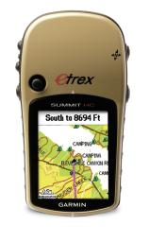
Safety Reminders
- Do not cross large streams.
Page
In/Out Zoom
- No Running.
- Stay on the trails.
Power
- Stay with your group.
Menu
- Respect the park.
- Return on time.

